

FACULTY OF TECHNOLOGY

SCHOOL OF COMPUTER SCIENCE

Restaurants total Sales predictions and Status in a period of time prediction using Machine Learning

**Student Name: Fung Yue (Lewis)**

**Project Supervisor: Dr. Simon Yiu, Dr. Ming Jiang and Dr. King-Hong Cheung**

# ABSTRACT

This research is intended to find the best machine learning model and use machine learning as the main method of performing new Restaurants opening predictions with different settings to provide some predictive insights for customers and is based on private data from Ambros Soft Ltd - Hong Kong Restaurants and public data from the Hong Kong Government Public Data Site (Ref. [Restaurant Receipts and Purchases](https://data.gov.hk/en-data/dataset/hk-censtatd-tablechart-qsr)). This research provided a literature review of related works and demonstrated a complete methodology and result assessment with visualization of results. The research models have also followed a varies machine learning methodology, eg. deep learning. To predict the location of Restaurants, Keras regression, and the Form of Restaurants, timeframes, payments, and employers were used. The model of deep learning with regression relies on features to predict overall restaurant sales. To predict whether the client can open restaurants or not, classification models will be considered and used. Additionally, in the case of overall sales, the algorithms k neighbor regression and random forest regression work best, while in the case of restaurant opening, the algorithms k neighbor regression and random forest regression work best. The results of the model show that using random forest regression to determine whether or not a customer would open a restaurant can be useful.

Keywords: Supervised Learning, Classification, Regression, Support Vector Regression (SVR), Restaurants Opening Prediction, Sales Prediction and Keras

Contents

ABSTRACT 2

**CHAPTER 1:** 8

**INTRODUCTION** 8

**1.1** **Project Overview** 8

**1.2** **Client’s Overview** 8

**1.3** **Client Requirements** 9

**1.4** **Project Objectives** 9

**1.5** **Constraints** 10

**1.6** **Relevance to Program** 10

**1.7** **Chapter Structure** 10

**CHAPTER 2:** 12

**LITERATURE REVIEW** 12

**2.1** **Introduction** 12

**2.2** **Restaurants Status and Revenue Predictions** 12

**2.2.1** **Restaurant Status Predictions** 12

**2.2.2** **Data source reference and linkage** 13

**2.2.3** **Feature set and target** 13

**2.2.4** **Method Algorithms** 13

**2.3** **Machine Learning** 14

**2.3.1** **Why Use Machine Learning?** 14

**2.3.2** **Types of Machine Learning Algorithm** 14

**2.3.3** **Decision Tree (DT)** 15

**2.3.4** **Support Vector regression (SVR)** 15

**2.3.5** **Random Forest Regression** 16

**2.3.6** **K-Nearest Neighbor Regression (KNN)** 16

**2.3.7** **Artificial neural networks (ANN)** 16

**2.4** **Chapter Summary** 18

**CHAPTER 3:** 20

**RESEARCH METHODOLOGY** 20

**3.1** **Introduction** 20

**3.2** **Data Science Analysis / Exploratory Data Analysis (EDA)** 20

**3.2.1** **Understand the Data / Data Preparation** 21

**3.2.2** **Frame the Problem** 22

**3.2.3** **Select the Tool** 23

**3.2.4** **Data Preparation** 25

**3.2.5** **Model Analyze** 25

**3.2.6** **Present the Results** 25

**3.2.7** **Deploy the Model** 25

**3.3** **Methodology** 25

**3.4** **Evaluation Methods** 43

**3.5** **Chapter Summary** 44

**CHAPTER 4:** 45

**RESULTS AND EVALUATIONS** 45

**4.1** **Results** 45

**4.2** **Discussions** 80

**4.3** **Chapter summary** 80

**CHAPTER 5:** 81

**CONCLUSIONS** 81

**5.1** **Key Findings** 81

**5.2** **Limitations** 81

**5.3** **Recommendations and Further Studies** 81

**5.4** **Social, Ethical, Professional and Legal Issues** 81

**5.5** **Putting it Together: Conclusions** 82

**References** 83

Figure 1: Importing Libraries 25

Figure 2: Reading the dataset 25

Figure 3: Checking Null Values in each column 26

Figure 4: Viewing the overall status 26

Figure 5: Code for Boxplot 27

Figure 6: Co relation between variables 27

Figure 7: Selection of X and Y for classification algorithm 28

Figure 8: Train and test splitting the data 28

Figure 9: Support vector machine for restaurant status Prediction 29

Figure 10: Logistic Regression for restaurant status Prediction 29

Figure 11: Decision tree Classifier for restaurant status prediction 30

Figure 12: Random Forest Classifier for restaurant status prediction 30

Figure 13: Ridge Classifier for restaurant status prediction 31

Figure 14: SGD Classifier for restaurant status prediction 31

Figure 15: K Neighbor Classifier for restaurant status prediction 32

Figure 16: Multi-layer perception neural network for restaurant status prediction 32

Figure 17: Deep Sequential neural network for restaurant status prediction 35

Figure 18: Combined Plot for accuracy of each classifier 35

Figure 19: K-fold cross validation on random forest 36

Figure 20: Selection of Variables for Regression Algorithms 37

Figure 21: Train Test split on regression algorithms 37

Figure 22: Random forest regression for total sales prediction 38

Figure 23: K Neighbor Regression for total sales Prediction 38

Figure 24: Decision Tree Regression for Total sales prediction 39

Figure 25: Gradient Boosting Regression for Total Sales Predictions 39

Figure 26: MLP Regression for total sales prediction 40

Figure 27: Neural Networks for total sales predictions 40

Figure 28: Code for combined plot of origional and predicted total sales for all algorithms 41

Figure 29: Code for combined mean square error plot for regression algorithms 41

Figure 30: Cross Validation for K Neighbor Regression for total sales prediction 42

Figure 31: Null Values of each columns 44

Figure 32: Count of Restaurant Status 45

Figure 33 Boxplot visualization for restaurant type 45

Figure 34: Boxplot visualization for restaurant area 46

Figure 35: Boxplot visualization for Districts 46

Figure 36: Boxplot of Number of people able to work from age 15 to 19 base on District 47

Figure 37: Boxplot of Number of people able to work from age 20 to 24 base on District 47

Figure 38: Boxplot of Number of people able to work from age 25 to 29 base on District 48

Figure 39: Boxplot of Number of people able to work from age 30 to 34 base on District 48

Figure 40: Boxplot of Number of people able to work from age 35 to 39 base on District 49

Figure 41: Boxplot of Number of people able to work from age 40 to 44 base on District 49

Figure 42: Boxplot of Number of people able to work from age 45 to 49 base on District 50

Figure 43: Boxplot of Number of people able to work from age 50 to 54 base on District 50

Figure 44: Boxplot of Number of people able to work from age 55 to 59 base on District 51

Figure 45: Boxplot of Number of people able to work from age 60 to 64 base on District 51

Figure 46: Boxplot of Number of people able to work from age 65 and above base on District 52

Figure 47: Boxplot of Number of people able to work from age 15 to 19 base on Area 52

Figure 48: Boxplot of Number of people able to work from age 20 to 24 base on Area 53

Figure 49:Boxplot of Number of people able to work from age 25 to 29 base on Area 53

Figure 50: Boxplot of Number of people able to work from age 30 to 34 base on Area 54

Figure 51: Boxplot of Number of people able to work from age 35 to 39 base on Area 54

Figure 52: Boxplot of Number of people able to work from age 40 to 44 base on Area 55

Figure 53: Boxplot of Number of people able to work from age 45 to 49 base on Area 55

Figure 54: Boxplot of Number of people able to work from age 50 to 54 base on Area 56

Figure 55: Boxplot of Number of people able to work from age 55 to 59 base on Area 56

Figure 56: Boxplot of Number of people able to work from age 60 to 64 base on Area 57

Figure 57: Boxplot of Number of people able to work from age 65 and above base on Area 57

Figure 58: Boxplot of total sales 58

Figure 59: Boxplot of Number of transactions 58

Figure 60: Boxplot of sqf 59

Figure 61: Boxplot of monthly rent 59

Figure 62: Boxplot of restaurant types 60

Figure 63: Boxplot of location types 60

Figure 64: Co relation plot for all features 61

Figure 65: Results of Support Vector Machine Classifier for Restaurant Status Predictions 62

Figure 66: Results of Logistics Regression for Restaurant Status Predictions 63

Figure 67: Result of decision tree Classifier for restaurant status prediction 64

Figure 68: Results of random forest for restaurant status prediction 65

Figure 69: Results of ridge classifier for restaurant status Prediction 66

Figure 70: Results of SGD Classifier for restaurant status prediction 67

Figure 71: Results of K Neighbor classifier for restaurant status predictions 68

Figure 72: Results MLP classifier for restaurant status predictions 69

Figure 73: Restaurants Recommendations accuracy comparisons 70

Figure 74: K fold validation step-1 results 70

Figure 75: K Fold validation step 2 results 71

Figure 76: K Fold Validating step 3 results 72

Figure 77: Random Forest Regression total sales predictions original and Predicted results for test data points 73

Figure 78: K Neighbor Regression total sales predictions original and Predicted results for test data points 73

Figure 79: Decision Tree Regression for total sales predictions original and Predicted results for test data points 74

Figure 80: Gradient Boosting Regression for total sales predictions original and Predicted results for test data points 74

Figure 81: MLP Regression for total sales predictions original and Predicted results for test data points 75

Figure 82: Neural Network Regression for total sales predictions original and Predicted results for test data points 75

Figure 83: Combined plot for regression results 76

Figure 84: Mean Squared Algorithm for each algorithm to predict sales 76

Figure 85: K Fold Validation Split 1 results 77

Figure 86: K Fold Validation Split 2 results 77

Figure 87: K Fold Validation split 3 results 78

Figure 88: K Fold Validation split 4 results 78

Figure 89: K Fold Validation split 5 results 79

# **CHAPTER 1:**

# **INTRODUCTION**

## **Project Overview**

The Hong Kong restaurant industry is mature and saturated, and growth in this industry is primarily driven by the overall growth of the local economy. Revenue for the restaurant sector fell 5.9 per cent to HK$112.5 billion (US$14.5 billion) in 2019 from the previous year, according to provisional data from the Census and Statistics Department released on https://www.censtatd.gov.hk/en/

In Hong Kong, there are various locations where restaurant’s owner could be considered to start a new business. However, when people want to open a new restaurant but don't know anything about the area, district, or other variables, they'll have a harder time planning and budgeting for it than open a restaurant based on data and evidence (Patel et al., 2011), To prepare this study and find the best approach for opening a restaurant in Hong Kong, we will leverage restaurant point of sales data given by Ambros Soft Ltd(Ambros), public data from Hong Kong government website and property agency website.

Identifying and investigating parameters and variables that influence restaurant’s revenue and able to predict whether the business can be sustainable for at least a period of year are the most difficult aspects of forecasting. Those variables corelated from location, revenue, age group, etc.. all play a role of analyzing factors. (KIM, H. & GU, Z. 2006) used logistic regression analysis for predicting bankruptcy in the restaurant industry and discovered that this information influences the market at a certain extent (Kim and Upnejy, 2014). In this area, there are numerous academic and commercial publications available, but only a portion of them is accessible to the public, such as F. M. T. Hossain, M. I. Hossain and S. Nawshin, used supervised machine learning (ML) techniques analysis to predict proliferation of location prediction; (LIAN, J., ZHANG, F., XIE, X. & SUN, G. 2017) provided statistical formula to calculate restaurant survival indicator.

## **Client’s Overview**

Ambros (http://www.ambrossoft.com) is a company that specializes in providing food and beverage (F&B) solutions. Ambros will continuing to develop new services and cloud-based products in order to maintain their rapid growth of business. In this project, Ambros assigned me the task of finding the best ML algorithms for their new product/services planning offer in coming years. Every restaurant owner in the technological era wanted to use big data to boost revenue. This project's target client is to address the need of all restaurant business owner who wants to open a new restaurant in selected or planned location in Hong Kong city and wants to know whether it will be able to sustain the growth of the business in a period of time with supported by sales revenue forecast from this project.

**Research questions: the aim of the analysis is to find an answer for client in TWO questions.**

**1. If we can predict whether or not after a period of time the restaurant on their location is still open (survive). The ML classification algorithms will be used to answer the classification question.**

**2. We will predict a restaurant revenue based on its private data from Ambros’s Point of Sales (POS) with real estate and government public data. This is a regression problem, and ML regression algorithms are used to solve this question.**

## **Client Requirements**

Since Ambros' s clients are restaurant owners, they aren't interested in math or ML, but they do want the best end result of forecasting restaurant sustainability according to different variables after a period of time and revenue for their restaurant. Their client wanted to know if they could open a restaurant in Hong Kong based on various data. These restaurant owners are also curious about the sales of other restaurants based on various variables so that they can estimate their own revenue.

* Use the public data of the Hong Kong restaurant, government population and real estate as the main dataset.
* Investigate and adopt ML approaches to prepare this research.
* Design and develop an indication model for the best location and revenue forecast.
* Provide comprehensive documentation, report and model results, including limitations and future suggestions.

## **Project Objectives**

The goal of this research is to use ML models as methods for predicting sustainability by Ambros data named as “restaurant status” and revenue in a variety of settings, including features sections and cross validations. It is necessary to provide restaurant owners with information.

The objectives of this research are listed below.

* To conduct literature review on restaurant status and revenue prediction techniques, methodologies and frameworks.
* To investigate the insight of data design and development with ML models. (eg. K Neighbors, Random Forest, Neural Networks etc.).
* To investigate restaurant statistical based on features like number of people available in districts and area with age group.
* To develop cross validation framework to predict the “status” of restaurant and revenue.
* To develop Neural Networks to achieve the predictions outcome.
* To visualize original and predicted results.
* To obtain client’s evaluation on delivered the research to Ambros.

## **Constraints**

For this research few conditions would be constraints

* Limited literature review available.
* Limitation on the accuracy and features of the data due to sensitive information of different restaurants which we only have around 5000 restaurant data provided by Ambros.
* Limited time to reach a certain level of accuracy for train and test.
* Missing some variable factors which could be useful for this research

1. Restaurant operational efficiency in each shop.
2. Chef capability and “Star Chef” effect.
3. Seasonality of food ingredients from varies suppliers.
4. Different ingredient supplier pricing strategy to restaurant owner.
5. Online comment of the restaurant.
6. Logistic and cost control from chain restaurant group with Central Kitchen Management.
7. Non-financial growth measures include growth of restaurant employment, customer satisfaction and loyalty program (Brown and Mitchell, 1993).

## **Relevance to Program**

This MSc Data Science final project focuses mainly on research, design and development of effective solutions to real-life data problems in the hospitality – restaurant sector. The aim of this research was to solve the problem of restaurant sustainability and revenue prediction by using supervised learning. In this course, supervised learning as a subset of ML is part of the syllabus, CETM 50 and ML and Data Analytics (CETM 24) introduce the concept of AI and ML and the applicability of algorithms. CETM24 explained the Data Science Foundation and CETM46 explained the design, development and best practice of data visualization for data products. Documentation on the reports, research methodology and literature review studies covered by CETM 47 is also adopted.

## **Chapter Structure**

**Chapter 1:** This chapter is a brief introduction to this study and the motivation of the problem or question statements. It also covers client’s information, requirements, project objectives and the constraints.

**Chapter 2:** Literature review is conducted which involved the restaurant predictions, operations and methods of ML regression and classification.

**Chapter 3:** This chapter introduces comprehensive view on the whole ML models, the methodology, assumptions, procedures, and evaluation methods.

**Chapter 4:** This chapter discusses about the results and evaluations on the ML models.

**Chapter 5:** This chapter summarizes the main key findings on ML models. Also, it provides recommendations, limitations and further research directions of this research. Also, the social ethical professional and legal issues will be discussed.

# **CHAPTER 2:**

# **LITERATURE REVIEW**

## **Introduction**

This chapter will present all related researches to this study (2 questions) and then examine the theories that underpin them in order to determine if the framework in this research is convincing and has adequate academic support.

## **Restaurants Status and Revenue Predictions**

The Ambros’s POS historical data will be recommended in this research. In literature review currently, this exact topic has not been studied. But some researches on restaurant data is done and revenue forecasting is also presented in relevance research accordingly. Based on our literature review on the factors influencing of restaurants, we collect information from two different types of data: (1) Data is not publicly available which provided by the client - Ambros, and (2) Publicly available data from Hong Kong Government and real estate agency website.

I firstly elaborate the data provided by Ambros, which contain information about restaurants and mainly serve as a ground-truth, i.e. labelled data for supervised ML. Next, I describe various web data sources collected to derive the indicating factors, which serve as input features to train multiple prediction models. I had also used Ambros’s restaurant data to predict the sales revenue (Rickard Adolfsson, Eric Andersson, George Osipov, 2019) but here in our case we have individual restaurant, so forecasting algorithms may not be fully applied here. The best thing to do for both cases is to apply supervised ML algorithms (LASEK, A., CERCONE, N. & SAUNDERS, J. 2016).

### **Restaurant Status Predictions**

The restaurant survival indicator (LIAN, J., ZHANG, F., XIE, X. & SUN, G.) is the most important factor to identify our Restaurant Status prediction statement. The journal provides similar problem statement from my planning project, eg, the restaurant which belong to normal shops (still operating) or closed shops (no more operation) categories for study. It leads to ask, can the restaurant survival prediction be solved using ML. The journal examine the performance of decision tree(DT) and supported vector machine (SVM). This paper also discusses the problem of restaurant survival prediction by modelling four perspectives: geographical metrics, user mobility, rating scores, and review text. Accordingly, in our dataset from Ambros, we also include geographical data and related categories.

### **Data source reference and linkage**

From <http://www.yelp.com> (Yelp) data reference from (Mr. N. Varatharajan1 , J. Guruprasad , K. Mathumitha ), the journal proposed propose a ML algorithms to resolve the issues of personalized restaurant selection relying upon Yelp data. It contains 10,000 No of restaurants with restaurant location, menu item and ratings. From our data source – Ambros provide more than 5000 individual restaurant data similar to Yelp. Data quality management is a crucial challenge in data management aiming at an improved usability and reliability of the data. Entity identification is defined as the detection and merging of two or more records representing the same real world identity across multiple data sets, which is relevant in duplicate detection and elimination as well as data integration. Apart from data cleaning, data integration and data warehousing, entity identification is closely related to information retrieval, pattern recognition and data mining as well, thus, making use of ideas from several research areas (Bilenko et al., 2003).

### **Feature set and target**

The first set of variables includes detailed information about the restaurant's start date, year, payment type, location type, restaurant type, and revenue. The second dataset from the government and real estate agency includes district worker age ranges ranging from 20 to 65 plus, monthly rent, and restaurant size. These variables are related to each other (Khan, Pathan Mohsin. 2018). The next step is to retrieve the target and features from the dataset. When it comes to the target variable, it's important to keep in mind that smaller sample sizes can lead to inaccurate results. The need for a minimum number of subjects underlines the importance of data sharing initiatives such as Openneuro.org (https://openneuro.org/) and schizconnect (<http://schizconnect.org>)

### **Method Algorithms**

Restaurant growth is a highly complex mechanism, thus predicting the growth of restaurants requires ML algorithms which are capable to handle a high level of complexity. Therefore, we use varies ML models, which are able to model complex interactions between the input variables and thus, share a predominant role in a range of research domains (Cutler et al. 2007). Reference from the journal (ML based class level prediction of restaurant reviews). They used four algorithms to build a model using a training dataset. These are Multinomial Naïve Bayes (MNB), Support Vector Machine (SVM) and K Nearest Neighbour (KNN). They used k-fold cross validation to measure the performance of our built in model, which is a very effective way to find the accuracy of the predictive model. It divides the data set into the training and testing set and calculates the performance and used 10 times in their experiment, which means k=10. logistic regression has produced the best result with more than 77% accuracy. The ML can be considered in our experiment as well.

## **Machine Learning**

### **Why Use Machine Learning?**

1. First, I'd look at how data is typically presented. In our case, I may notice that certain figures or numbers appear frequently in the subject. Perhaps I'd notice a few other patterns in the restaurant's name, the type of location, and so on.
2. I would write a detect algorithm for each of the patterns I noticed, and my program would flag as correlation of independent or dependent variable if several of these patterns were detected.
3. I'll test my program and repeat steps 1 and 2 until it's good enough.

Since the problem is not trivial, my program will most likely turn into a long list of complex rules that will be difficult to maintain. In practice, a ML based technique automatically learns which dependent and independent variables are good predictors of data changes and insight. The program will be much shorter, easier to maintain, and probably more accurate.

Appling ML is great for:

* Problem for which existing solution require a lot of hand-turning or long list of rules, ML algorithm can often simplify code and perform better.
* Complex problems for which there is no good solution at all: the ML techniques can find a solution.
* Fluctuating environments: a ML system can adapt to new data.
* Getting insights about complex problems and large amount of data.

The growing popularity of ML has led to the development of a number of tools designed to make the data or application of this approach accessible to the novice learning machine. These efforts have resulted in tools such as PRoNTo (Schrouff et al., 2013) and NeuroMiner (https://pronia.eu/neurominer/) that do not require programming skills. However, learning how to program a ML pipeline (even if it's a simple one) is an excellent way to gain insight into the strengths of this analytical approach as well as the potential "distortions" that may occur along the ML pipeline (Tandon & Tandon, 2018). It also allows greater flexibility, such as the use of any ML algorithm or data modality of interest.

In this chapter, we select different ML Models, and the discussion is taken from the official site of sklearn. (Shrove. 2020)

### **Types of Machine Learning Algorithm**

Since there are so many different types of ML algorithms, it's helpful to categorize them into large categories. For this research, I chose several ML algorithms that I learned from various MSc Data Science courses and referenced from other journals. Select a model is a condensed version of the data. The simplifications are intended to eliminate superfluous details that are unlikely to be generalizable to new instances. However, in order to determine which data to discard and which to keep, assumptions must be made. A linear model, for example, assumes that the data is fundamentally linear and that the distance between instances and the straight line is simply noise that can be safely ignored. David Wolpert demonstrated (D. Wolpert. 1996) that if no assumptions about the data are made, there is no reason to prefer one model over another. This is referred to as the No Free Lunch (NFL) theorem. A linear model is the best model for some datasets, while a neural network is the best model for others. There is no model that is guaranteed to work better from the start (hence the name of the theorem). The only way to know which model the best is to test them all. Because this is not possible, I must make some reasonable assumptions about the data and evaluate only a few reasonable models in practice. For example, for simple tasks, I could evaluate Decision Tree, Support Vector Regression, Random Forecast Regression models, K-Nearest Neighbor Regression, etc… with different levels of regularization, and for a complex problem, I could evaluate various neural networks, such as Artificial Neural Networks etc…

### **Decision Tree (DT)**

Decision Tree (DT) is a non-parametric regulated learning strategy utilized for characterization and relapse which we will using it in this research.

It can perform both classification and regression tasks, and even multioutput tasks. DT are also the fundamental components of Random Forests. (Reference of using this ML in other journals)

Formula:

Entropy at a give node t:

Entropy(t) = - $\sum_{j}{p}$ (j|t)log p(j|t)

NOTE: p(j|t) is the relative frequency of class j at note t.

(CETM24-decisiontrees.pdf)

The concept of entropy originated in thermodynamics as a measure of molecular disorder: entropy approaches zero when molecules are still and well ordered. I will use Scikit-Learn for the Classification And Regression Tree (CART) algorithm to train Decision Trees (also called “growing” trees).

### **Support Vector regression (SVR)**

The support vector machine (SVM) algorithm is to maximize the mar‐ gin (shown as below), which is defined as the distance between the separating hyperplane (or decision boundary) and the training samples that are closest to this hyperplane, the so called support vectors. The margin is calculated as the perpendicular distance from the line to only the closest points, as shown below. Hence, SVM calculates a maximum-margin boundary that leads to a homogeneous partition of all data points which I will apply to my case. (Reference of using this ML in other journals)

### **Random Forest Regression**

Random Forest is an ensemble of Decision Trees, generally train a group of Decision Tree classifiers, each on a different random subset of the training set. To make predictions, we just obtain the predictions of all individual trees, then predict the class that gets the most votes. Such an ensemble of Decision Trees is called a Random Forest, and despite its simplicity, this is one of the most common ML algorithms available today. The Random Forest algorithm introduces extra randomness when growing trees; instead of searching for the very best feature when splitting a node, it searches for the best feature among a random subset of features. This results in a greater tree diversity, which trades a higher bias for a lower variance, generally yielding an overall better model. Feature importance: Yet another great quality of Random Forests is that they make it easy to measure the relative importance of each feature. The tools Scikit-Learn measures a feature’s importance by looking at how much the tree nodes that use that feature reduce impurity on average (across all trees in the forest). More precisely, it is a weighted average, where each node’s weight is equal to the number of training samples that are associated with it. (Hyeonseob N. 2016)

### **2.3.6 K-Nearest Neighbor Regression (KNN)**

This is the K-Nearest Neighbor (KNN) solution, which performs exceptionally well. It takes two forms: a regression, where we want a value, or a classification. To apply KNN to my problem of restaurant Status, we would just have to find the nearest K neighbors.

The KNN algorithm was originally introduced by Drs. Evelyn Fix and J. L. Hodges Jr, in an unpublished technical report written for the U.S. Air Force School of Aviation Medicine. Fix and Hodges’ original research focused on splitting up classification problems into a few subproblems:

Sklearn.neighbors gives usefulness to solo and directed neighbors-based learning techniques. Solo closest neighbors are the establishment of numerous other learning techniques, remarkably complex learning and otherworldly grouping. Regulated neighbors-based learning comes in two flavors: order for information with discrete marks, and relapse for information with ceaseless names. (Thorsten G. 2020)

### 

### **2.3.7 Artificial neural networks (ANN)**

ANNs are at the very core of Deep Learning. They are versatile, powerful, and scalable, making them ideal to tackle large and highly complex ML tasks, such as classifying billions of images (e.g., Google Images), powering speech recognition services (e.g., Apple’s Siri), recommending the best videos to watch to hundreds of millions of users every day (e.g., YouTube).

ANN architectures leading up to Multi-layer Perceptron (MLP) is a regulated learning calculation that learns a capacity via preparing on a dataset, where is the quantity of measurements for input and is the quantity of measurements for yield. The Perceptron is one of the simplest ANN architectures, invented in 1957 by Frank Rosenblatt(Christoph Van. 1986). It is based on a slightly different artificial neuron called a threshold logic unit (TLU), or sometimes a linear threshold unit (LTU): the inputs and output are now numbers (instead of binary on/off values) and each input connection is associated with a weight. The TLU computes a weighted sum of its inputs (z = w1 x1 + w2 x2 + ⋯ + wn xn = xT w), then applies a step function to that sum and outputs the result: hw(x) = step(z), where z = xT w.

In the Multilayer perceptron, there can more than one linear layer (combinations of **neurons**). If we take the simple example the three-layer network, first layer will be the *input layer* and last will be *output layer* and middle layer will be called *hidden layer.*We feed the input data into the input layer and take the output from the output layer. We can increase the number of the hidden layer as much as we want, to make the model more complex according to my task.

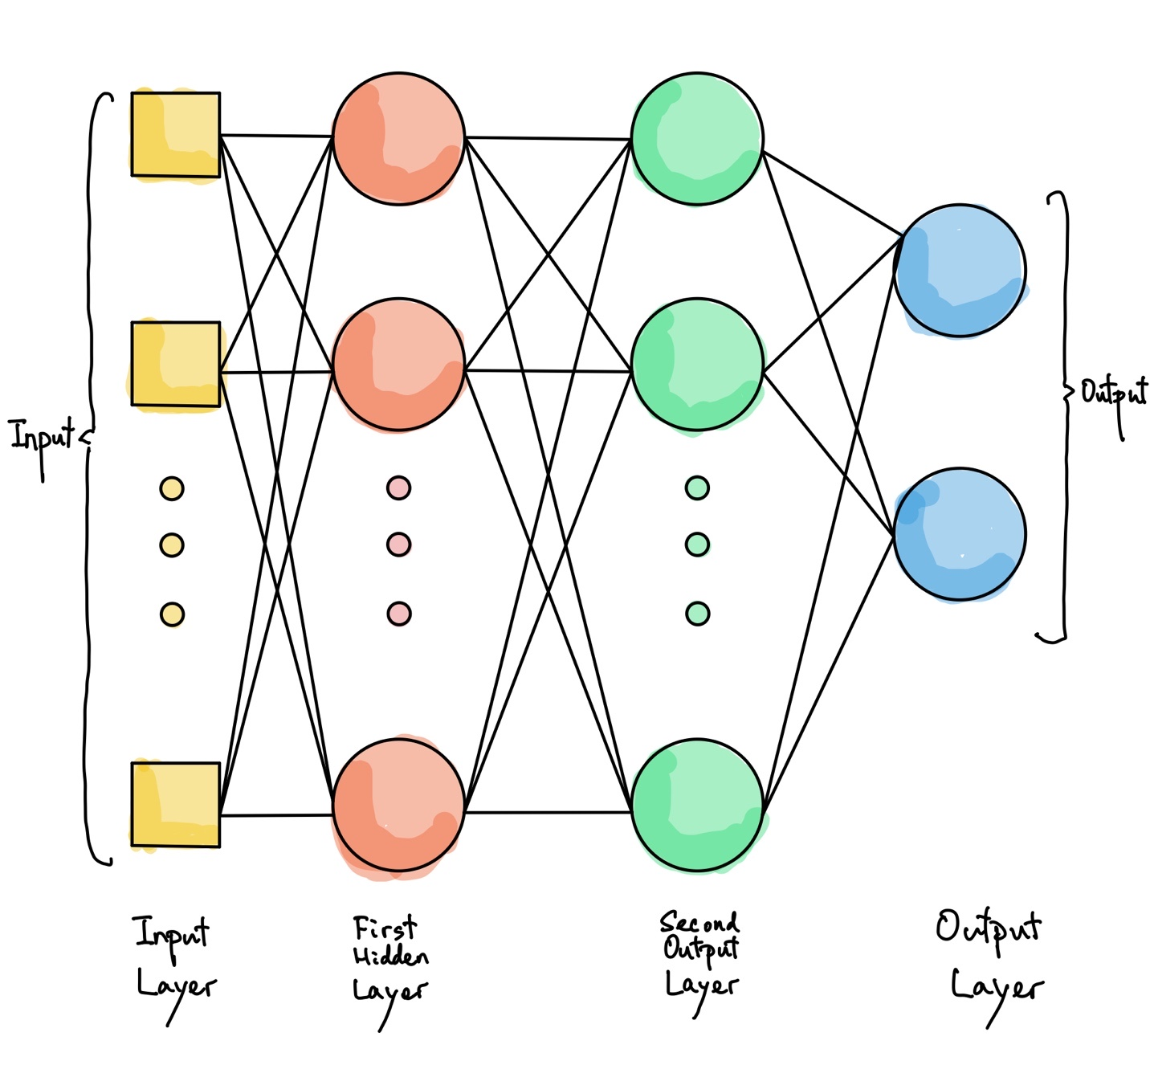

An MLP is composed of one (passthrough) input layer, one or more layers of TLUs, called hidden layers, and one final layer of TLUs called the output layer. The layers close to the input layer are usually called the lower layers, and the ones close to the outputs are usually called the upper layers. Every layer except the output layer includes a bias neuron and is fully connected to the next layer(Allan P. 1999).

## **Chapter Summary**

According to the search results, there are some researches were available for individual restaurants open recommendations using supervised data, but no specific topics is covered. Why ML in the restaurant industry? First, you may be surprised to learn that ML already helps restaurants in many ways by:

* Forecasting sales more accurately
* Identifying staff theft
* Matching customers to restaurants based on their pre-selected taste profile
* Teaching robots how to cook
* Identifying the contents of food at a molecular level

In this chapter, I provide a short definition of ML and discuss additional ways it can help the restaurant industry, specifically by addressing 2 questions also discussed here.

# **CHAPTER 3:**

# **RESEARCH METHODOLOGY**

## **Introduction**

This chapter is to introduce the comprehensive view on the data engine based on ML model of this research. The whole process obeys the lifecycle of data science: from problem statement, raw data, to data engineering, model building, evaluation and parameters tunings. At last, the result visualization and model deployment.

## **Data Science Analysis / Exploratory Data Analysis (EDA)**

In a work offered the lifecycle of data analysis and development. We often want a numerical prediction over a categorical target. In current Restaurant Status research, a basic yes/no prediction of whether a restaurant is likely to continue for keep the business running may not be sufficient; we want to model the probability that the restaurant will continue. This is still considered classification modeling rather than regression because the underlying target is categorical. The process includes main data from Ambros, Hong Kong government and property agency starting from identifying the problem to completed in result – deployment and insights illustration. There are six main stages including understanding the data, selecting appropriate tools and methodologies, data preparation, building a model, test it and analyze the results. Each stage has own scope of tasks and its own objectives. In the following subchapters will be shown main activities and jobs accomplished in this project at all stages. (Deanne Larson, Victor Chang, 2016)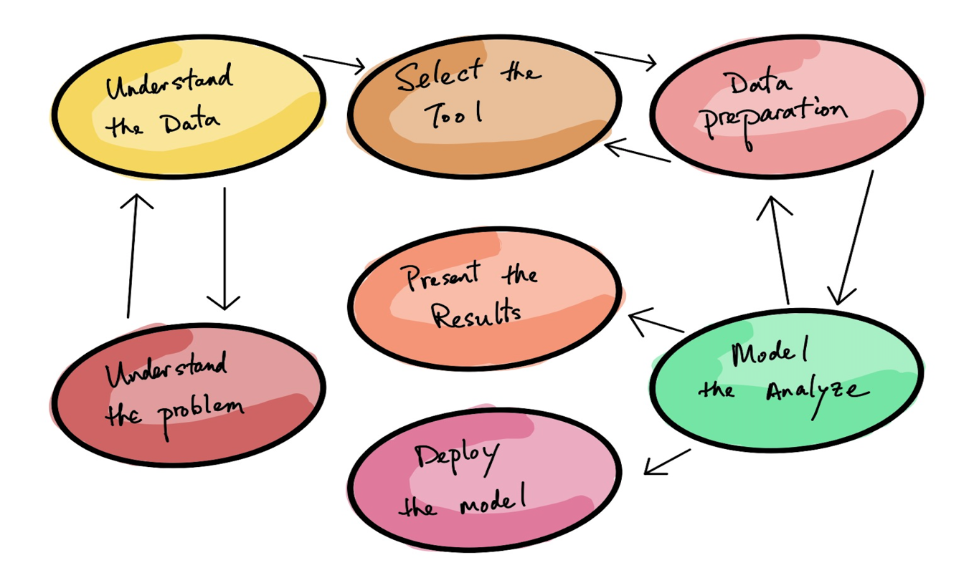

### **Understand the Data / Data Preparation**

The dataset available is containing the information of different restaurants of Hong Kong. The dataset has features based on ages, areas and different type of payments. With all these there were features of total sales and restaurant status. This makes the data supervised. Obviously, if Ambros gave us those data is full of errors, outliers, and noise (e.g., due to poor- quality measurements), it will make it harder for the ML to detect the underlying patterns, so it is less likely to perform well. It is often well worth the effort to spend time cleaning up our data. The truth is most data scientists spend a significant part of their time doing just that.

**Handling, cleaning, and preparing data**

* I found some instances are clearly outliers, it simply discards them or try to fix the errors manually.
* Some instances are missing a few features, I must decide whether I want to ignore this attribute altogether, ignore these instances, fill in the missing values (e.g., with the location or monthly rental price), or train one model with the feature and one model without it, and so on.
* Change the name of each restaurant to number and remove or change “Null” value
* There was some bad data because the restaurant type was sometimes not correct. I must change it. For example, if a restaurant name contained [restaurant, fast_food] “restaurant” in it, it was classified as a fast food restaurant but when double check from Openrice.com, it shows the other type.

We then formatted the data in preparation for machine learning. The following table presents an extract of the formatted data shows in figure 2.

**Feature Engineering**

I will only be capable of learning if the training data contains enough relevant features and not too many irrelevant ones. In our case, there are a lot of operational data which need to remove, eg. type of food, product type of restaurant, restaurant table number, different time sales revenue etc… A critical part of the success of a ML project is coming up with a good set of features to train on.

This process, called feature engineering, involves:

* Feature selection: selecting the most useful features to train on among existing feature.
* Feature extraction: combining existing features to produce a more useful one.
* Creating new features by gathering new data.

**Reviewing Ambros’s private data**

It could be underfitting data. It occurs when the model is too simple to learn the underlying structure of the data.

The key actions to fix this problem are:

* Selecting a more powerful model, with more parameters add on from public data. Eg. Government and Property agency data
* Feeding better features to the learning algorithm (feature engineering)
* Reducing the constraints on the model (e.g., reducing the regularization hyper‐ parameter)
* Using a 0 or 1 to denote the restaurant status from “Open” or “Close”

**The next step is**

1. Look at the big picture of those private and public data.

2. Combine all private and public data.

3. Discover and visualize both to Ambros, Government and Property agent gain insights.

4. Learning by fitting a model to those data.

5. Selecting and engineering features.

6. Selecting a model and tuning hyperparameters using cross-validation.

7. Present the solution.

### **Frame the Problem**

The first question to ask is what exactly the business objective is; building a model is probably not the end goal. How does the Ambros expect to use and benefit from the models? This is important because it will determine how we frame the problem, what algorithms we will select, what performance measure we will use to evaluate our model, and how much effort we should spend tweaking it. The next question to ask is what the current solution looks like (if any). It will often give us a reference performance, as well as insights on how to solve the problem, with all this information we are now ready to start designing our code. First, we need to frame the problem: is it supervised, unsupervised, or Reinforce Learning? Is it a classification task, a regression task, or something else? Should we use batch learning or online learning techniques?

The main problem is to predict whether the location will be appropriate for opening a restaurant or not. Also, the main problem is the predict the total sales predictions of different restaurants.

Select a Performance Measure

Our next step is to select a performance measure. A typical performance measure for regression problems is the Root Mean Square Error (RMSE). It gives an idea of how much error the code typically makes in its predictions, with a higher weight for large errors.

Root Mean Square Error (RMSE)

RMSE(X,h) = $\sqrt{\frac{1}{m}}$ ${(h\left(x^{\left(i\right)}\right)-y^{\left(i\right)})}^{2}$

### **Select the Tool**

There are various programing languages and interfaces that could provide us the implementation of ML algorithms to classify the normal source packets from the attack source packets. One of the widely used language for this purpose is Python. Jupyter Notebook or Google colab is an interactive interface and make flow interactive and understandable.

#### **Prerequisites**

This research assumes that we have some Python programming experience and familiar with Python’s main scientific libraries, in particular NumPy, Pandas, and Matplotlib. Also, understanding of (calculus, linear algebra, probabilities, and statistics) and Python <http://learnpython.org/>

#### **Python Programming Language:**

The Python programming language is setting up itself as one of the most well-known dialects for logical processing. The simplicity of Python has attracted many developers to create new libraries for machine learning, leading to strong adoption of Python. I will be using actual production ready Python frameworks:

Here is a brief summary of each of our packages:

**NumPy:** Provides support for large, multidimensional arrays as well as an extensive col‐ lection of mathematical functions.

**Pandas:** A library for data manipulation and analysis. Among other features, it offers data structures to handle tables and the tools to manipulate them.

**Matplotlib:** A plotting library that allows the creation of 2D charts and plots.

**SciPy:** The combination of NumPy, Pandas, and Matplotlib is generally referred to as SciPy. SciPy is an ecosystem of Python libraries for mathematics, science, and engineering.

**Scikit-learn (or sklearn):** A machine learning library offering a wide range of algorithms and utilities. It’s very easy to use, yet it implements many ML algorithms efficiently, so it makes for a great entry point to learn ML.

**Keras:** An artificial neural network library that can act as a simplified interface to TensorFlow/Theano packages. It’s high-level Deep Learning API that makes it very simple to train and run neural networks.

**Seaborn:** A data visualization library based on Matplotlib. It provides a high-level interface for drawing attractive and informative statistical graphics.

**pip and Conda:** These are Python package managers. pip is a package manager that facilitates installation, upgrade, and uninstallation of Python packages. Conda is a package manager that handles Python packages as well as library dependencies outside of the Python packages.

**Steps for Model Development in Python Ecosyste*m:***

Working through machine learning problems from end to end is critically important.

Figure below provides an outline of the simple seven-step machine learning project template that can be used to jump-start any machine learning model in Python. The first few steps include exploratory data analysis and data preparation, which are typical data science based steps aimed at extracting meaning and insights from data. These steps are followed by model evaluation, fine-tuning, and finalizing the model.

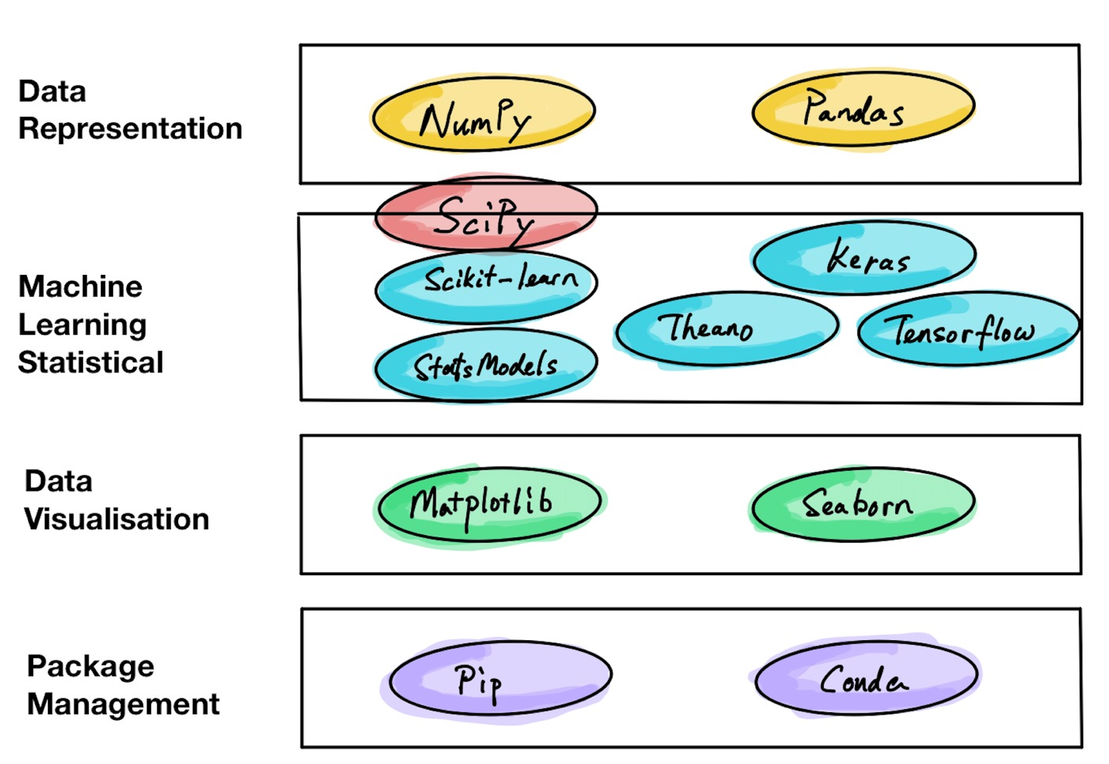

Figure above. Model development steps

In our case, follow the standard seven-step model development process, renamed, or reordered based on the appropriateness and intuitiveness of the steps. The following section covers the details of each model development step with supporting Python code.

Problem definition

The first step is defining our problem – 1 and 2 . Select or some powerful algorithms can be used for solving the problem, but the results will be meaningless if the wrong problem is solved.

### **Data Preparation**

Data was prepared for train and test while selecting the important features using human intelligence. These features were important as they all were helping in basis of Restaurant Open and Sales.

### **Model Analyze**

Models were analyzed using accuracy and confusion matrix and confusion report for classification matrix and mean squared errors for the regression models.

### **Present the Results**

The results were presented using plotly library. The accuracy for all classification models were printed together to show the best model. The mean squared error for all regression algorithms was plotted together to get the best algorithm with lowest error.

### **Deploy the Model**

The best models for both cases were then passes through the K Fold Cross Validation Techniques for their final selections.

## **Methodology**

The components of the ML pipeline in our example are problem formulation, data planning, feature engineering, model training, model evaluation, and post-hoc analysis. We must first import all of the required libraries, set the random seed to a fixed value, and organize our workspace before we begin. The project was also implemented in python program and it’s a sequence of code and running it randomly may cause the error as the coding is a step-by-step process. So, it is important to consider this while running the code.

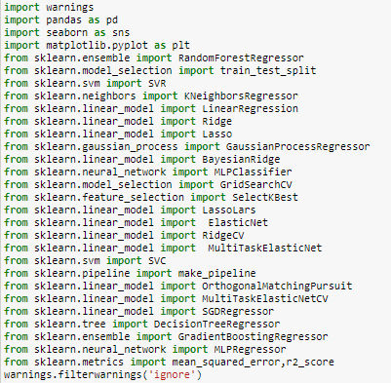

Figure 1: Importing Libraries

The libraries are discussed in previous sections were imported at the first place. Warnings are used to avoid any warning that may occur during coding process.

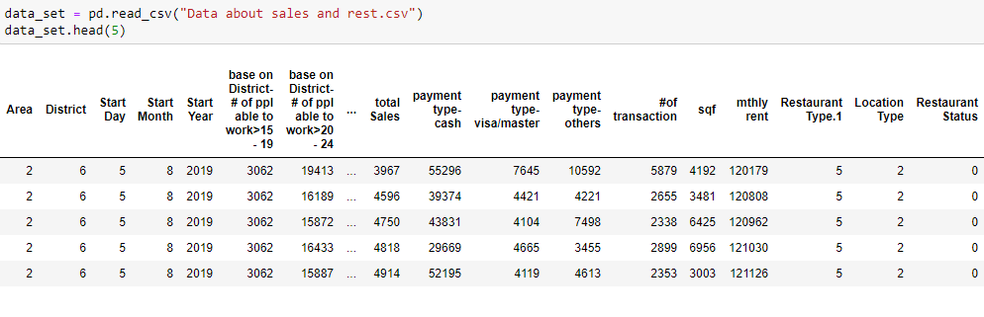

Figure 2: Reading the dataset

The dataset was read using the pandas read csv method. We know the value for the target attribute. It is a classification problem because the target is a category (yes or no) for Restaurant Status which I had changed to 1 = yes, 0 = no when I did the data mining.

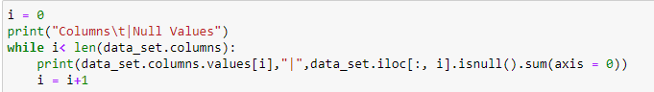

Figure 3: Checking Null Values in each column

Null values for each column were checked using the code in figure 3.

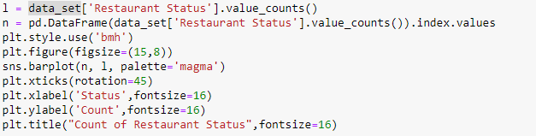

Figure 4: Viewing the overall status

For checking how much data of Restaurant status were available the value counts for both open and close was done.

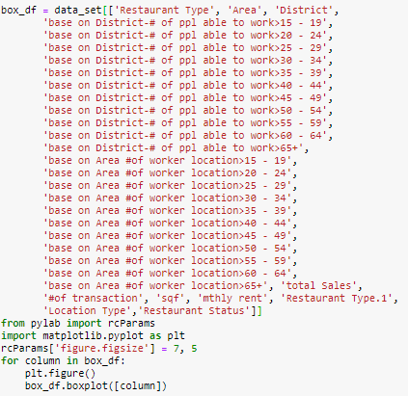

Figure 5: Code for Boxplot

Boxplot code is used to get insights of each feature that will help for overall status of the data from business point of view.

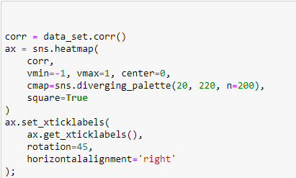

Figure 6: Co relation between variables

The co relation between all variables was checked and plotted using the above code.

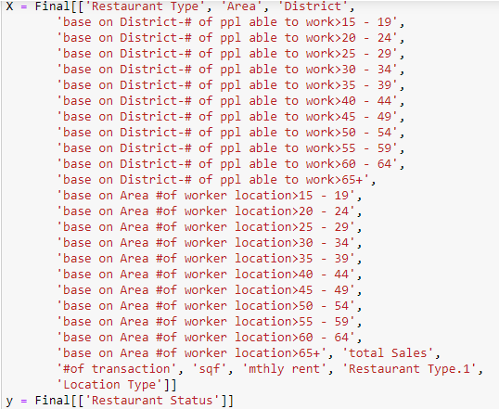

Figure 7: Selection of X and Y for classification algorithm

First step was to use the Classification Algorithms to predict the restaurant stats. In figure 7 the target and the inputs were splitter into X and y.



Figure 8: Train and test splitting the data

33 % of the data was chosen as the test size to get the maximum accuracy in future.

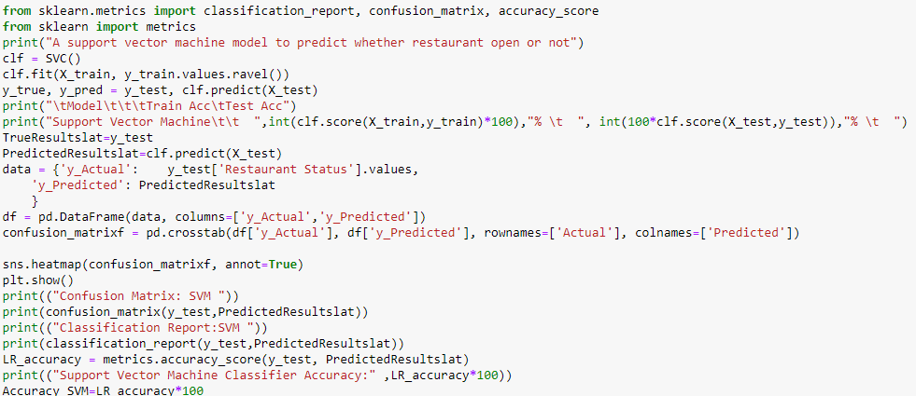

Figure 9: Support vector machine for restaurant status Prediction

The above code is showing the implementation of ML Algorithms for restaurant predictions.

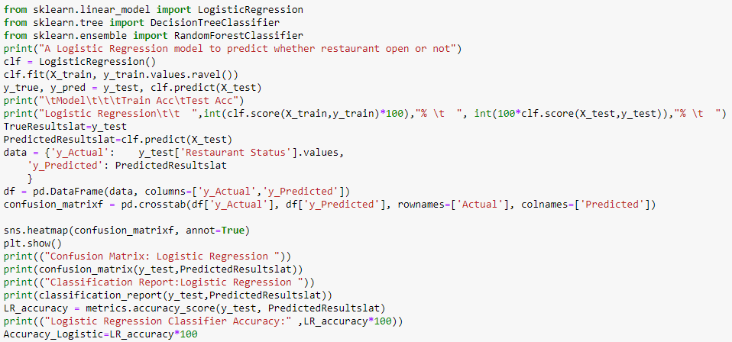

Figure 10: Logistic Regression for restaurant status Prediction

The above algorithm is showing the implementation of Logistics Regression for the restaurant status prediction.

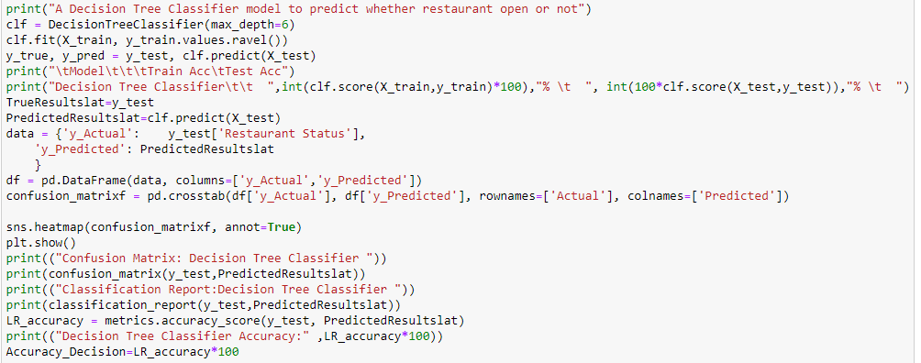

Figure 11: Decision tree Classifier for restaurant status prediction

The above code is showing the implementation of Decision Tree Classification for the restaurant status prediction.

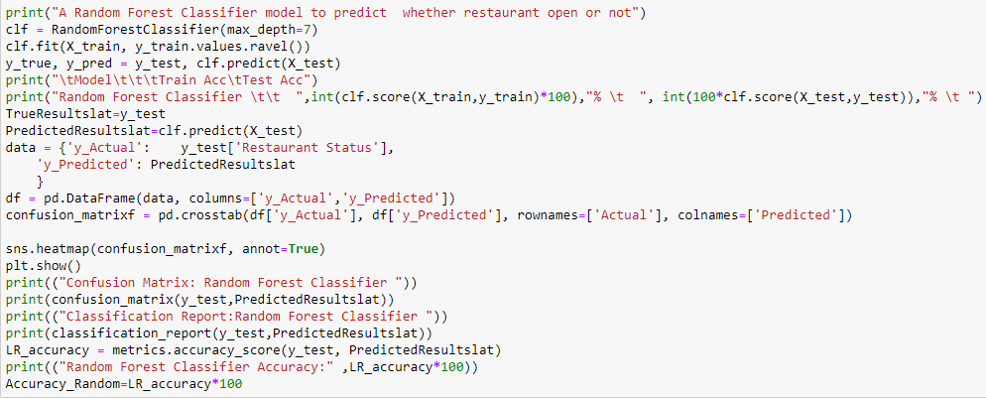

Figure 12: Random Forest Classifier for restaurant status prediction

The above code is showing the implementation of Random Forest Classification for the restaurant status prediction.

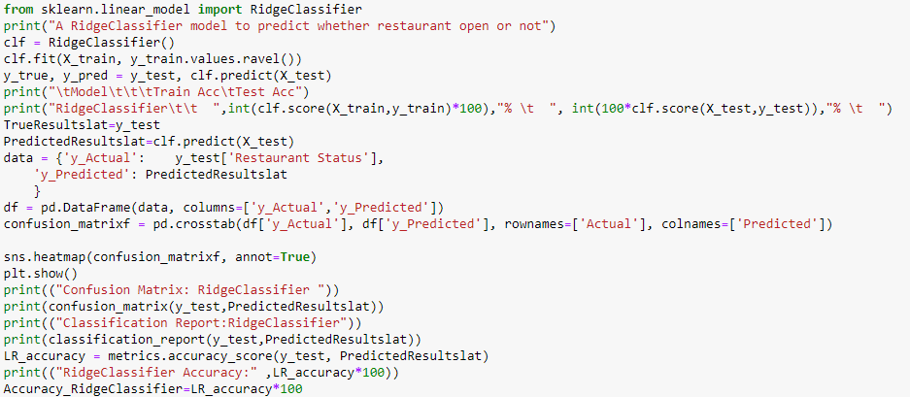

Figure 13: Ridge Classifier for restaurant status prediction

The above code is showing the implementation of Ridge Classification for the restaurant status prediction.

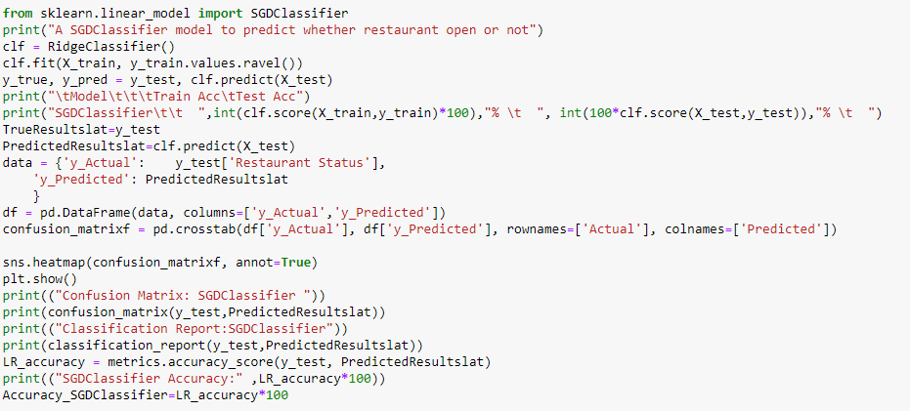

Figure 14: SGD Classifier for restaurant status prediction

The above code is showing the implementation of Stochastic Gradient Descent Classification for the restaurant status prediction.

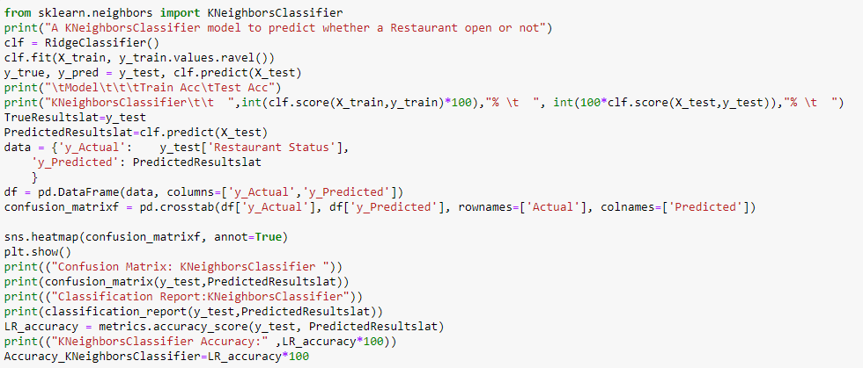

Figure 15: K Neighbor Classifier for restaurant status prediction

The above code is showing the implementation of K Neighbor Classification for the restaurant status prediction.

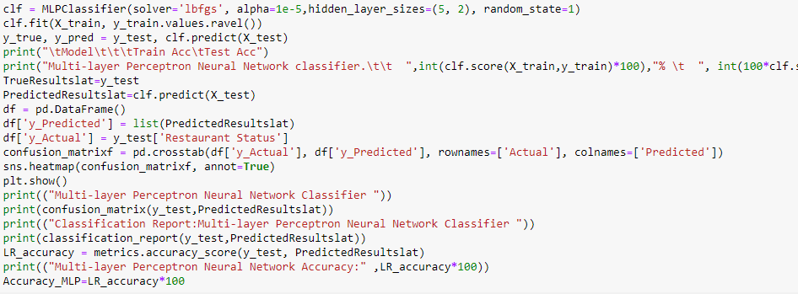

Figure 16: Multi-layer perception neural network for restaurant status prediction

The above code is showing the implementation of MLP on for the restaurant status prediction.

**Neural Network**

We used keras library for Neural Network. We create a [Sequential model](https://keras.io/models/sequential/) and add layers one at a time.

The first thing we ensure the input layer has the right number of input features. This is specified when creating the first layer with the **input_dim** argument and setting it to 8 for the 8 input variables.

We need a network large enough to capture the structure of the problem. We use a fully-connected network structure with three layers.

Fully connected layers are defined using the [Dense class](https://keras.io/layers/core/). We specify the number of neurons or nodes in the layer as the first argument and specify the activation function using the **activation** argument.

We use the [rectified linear unit activation function](https://machinelearningmastery.com/rectified-linear-activation-function-for-deep-learning-neural-networks/) referred to as ReLU on the first two layers and the Sigmoid function in the output layer.

It used to be the case that Sigmoid and Tanh activation functions Oure preferred for all layers. We used better performance using the ReLU activation function. We use a sigmoid on the output layer to ensure our network output is between 0 and 1 and easy to map to either a probability of class 1 or snap to a hard classification of either class with a default threshold of 0.5.

We piece it all together by adding each layer:

* The model expects rows of data with 8 variables (the input_dim=8 argument)
* The first hidden layer has 12 nodes and uses the relu activation function.
* The second hidden layer has 8 nodes and uses the relu activation function.
* The output layer has one node and uses the sigmoid activation function.

The shape of the input to the model is defined as an argument on the first hidden layer. This means that the line of code that adds the first Dense layer is doing 2 things, defining the input or visible layer and the first hidden layer.

Compiling the model uses the efficient numerical libraries under the covers (the so-called backend) such as Theano or TensorFlow. The backend automatically chooses the best way to represent the network for training and making predictions to run on hardware, such as CPU or GPU or even distributed.

When compiling, we specify some additional properties required when training the network. Training a network means finding the best set of weights to map inputs to outputs in our dataset.

We specify the loss function to use to evaluate a set of weights, the optimizer is used to search through different weights for the network and any optional metrics we would like to collect and report during training.

We use cross entropy as the **loss** argument. This loss is for a binary classification problems and is defined in Keras as “**binary_crossentropy**“.

We define the **optimizer** as the efficient stochastic gradient descent algorithm “**adam**“. This is a popular version of gradient descent because it automatically tunes itself and gives good results in a wide range of problems.

It is a classification problem, we collect and report the classification accuracy, defined via the **metrics** argument.

We have defined our model and compiled it ready for efficient computation.

We execute the model on some data.

We train or fit our model on our loaded data by calling the **fit()** function on the model.

Training occurs over epochs and each epoch is split into batches.

* **Epoch**: One pass through all of the rows in the training dataset.
* **Batch**: One or more samples considered by the model within an epoch before weights are updated.

One epoch is comprised of one or more batches, based on the chosen batch size and the model is fit for many epochs. For more on the difference between epochs and batches, see the post:

The training process run for a fixed number of iterations through the dataset called epochs, that we specify using the **epochs** argument. We also set the number of dataset rows that are considered before the model weights are updated within each epoch, called the batch size and set using the **batch_size** argument.

For this problem, we run for a small number of epochs (150) and use a relatively small batch size of 10.

We want to train the model enough so that it learns a good (or good enough) mapping of rows of input data to the output classification. The model always has some error, but the amount of error level out after some point for a given model configuration. This is called model convergence.

We have trained our neural network on the train dataset and we evaluate the performance of the network on the test dataset.

We evaluate Our model on Our testing dataset using the **evaluate ()** function on Our model and pass it the same input and output used to train the model.

This generate a prediction for each input and output pair and collect scores, including the average loss and any metrics We have configured, such as accuracy.

The **evaluate ()** function return a list with two values. The first be the loss of the model on the dataset and the second be the accuracy of the model on the dataset. We are only interested in reporting the accuracy, so we ignore the loss value.

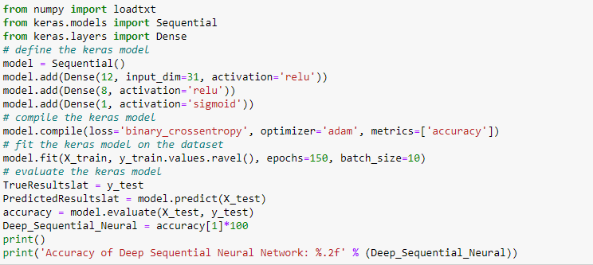

Figure 17: Deep Sequential neural network for restaurant status prediction

The above code is showing the implementation of deep sequential neural network classifier for the restaurant status prediction.

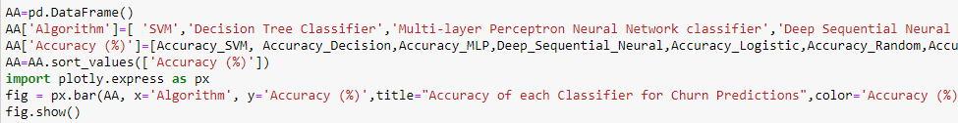

Figure 18: Combined Plot for accuracy of each classifier

Figure 18 is the code for combined plot for each Classifier.

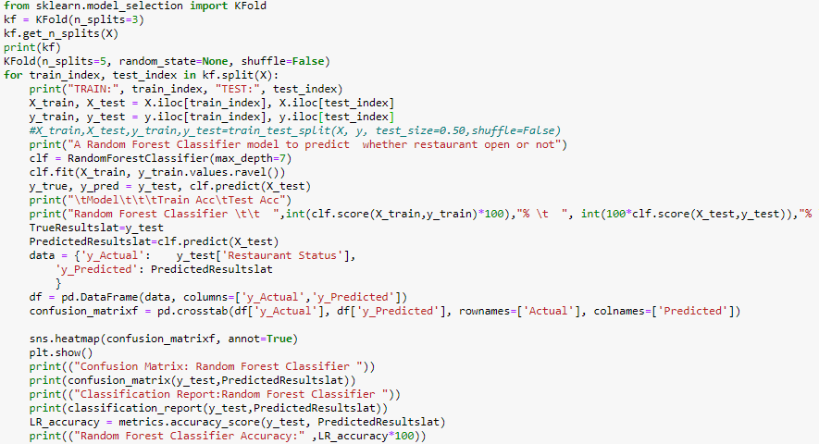

Figure 19: K-fold cross validation on random forest

From visualizations it was checked that Random Forest Classification is the best algorithm for this project. So, K Fold cross validation is done using sklearn K Fold Model.

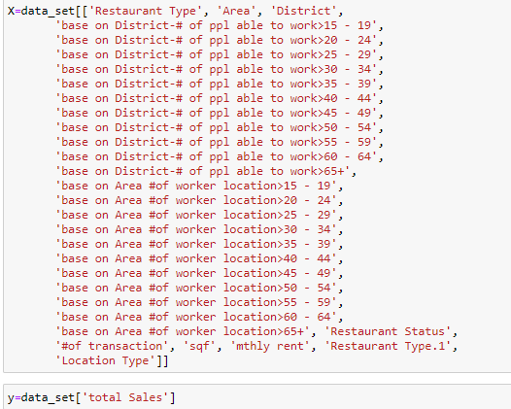

Figure 20: Selection of Variables for Regression Algorithms

The above code is showing the variable selection for the total sales prediction.



Figure 21: Train Test split on regression algorithms

The above code is showing the train and test splits of each algorithm.

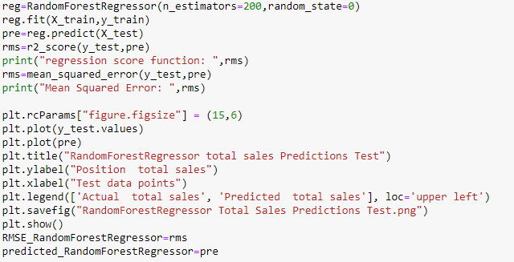

Figure 22: Random forest regression for total sales prediction

The above code is showing the implementation of Random Forest Regression for total sales prediction.

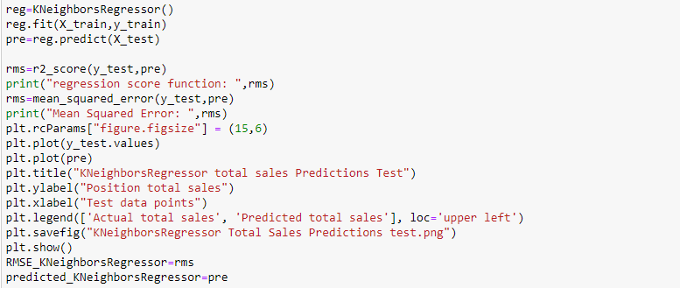

Figure 23: K Neighbor Regression for total sales Prediction

The above code is showing the implementation of K Neighbor Regression for total sales predcition.

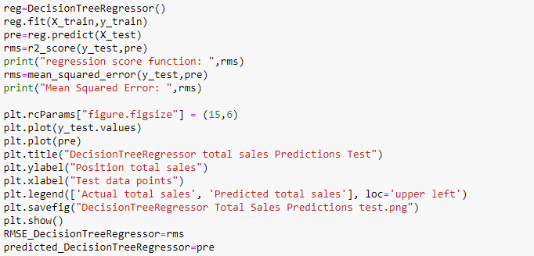

Figure 24: Decision Tree Regression for Total sales prediction

The above code is showing the implementation of Decision Tree Regression for total sales prediction.

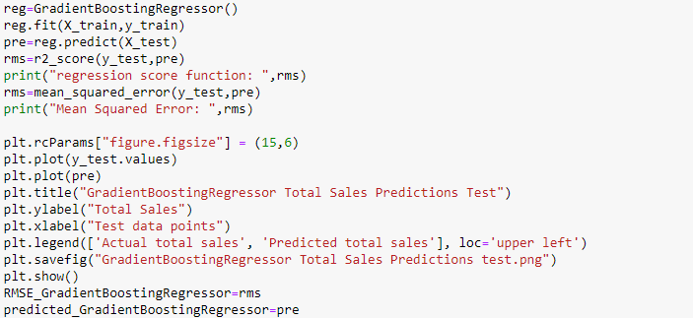

Figure 25: Gradient Boosting Regression for Total Sales Predictions

The above code is showing the implementation of Gradient Boosting Regression for total sales prediction.

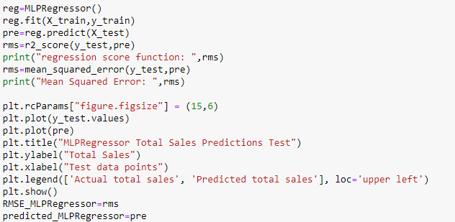

Figure 26: MLP Regression for total sales prediction

The above code is showing the implementation of MLP Regression for total sales prediction.

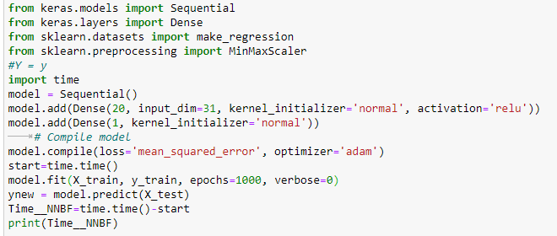

Figure 27: Neural Networks for total sales predictions

The above code is showing the implementation of Deep Sequential Neural Network Regression for total sales prediction.

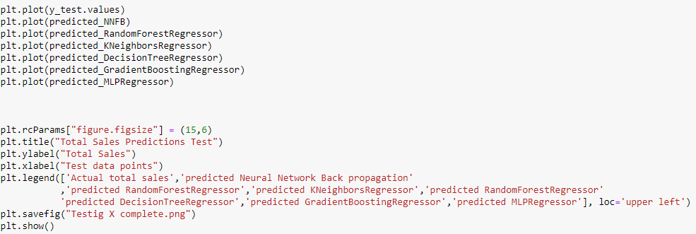

Figure 28: Code for combined plot of origional and predicted total sales for all algorithms

The above code is showing the combined plot for each algorithm.

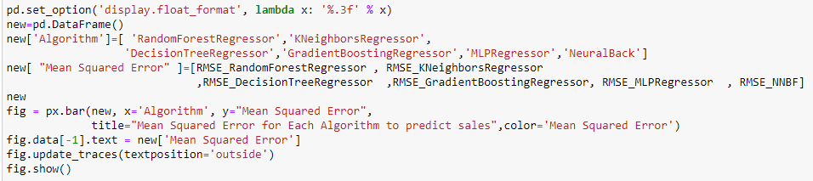

Figure 29: Code for combined mean square error plot for regression algorithms

The combined plot for mean squared error for each algorithm was plotted using this code.

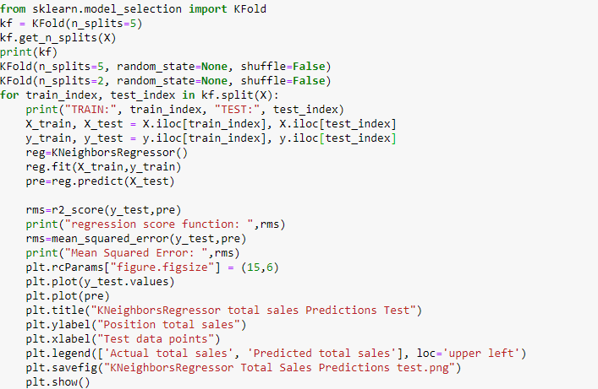

Figure 30: Cross Validation for K Neighbor Regression for total sales prediction

The last step I methodology was to apply cross validation techniques.

## **Evaluation Methods**

Accuracy Measures techniques used for Classification

- Mainly 4 techniques are used

#### Precision

Precision talks about how precise/accurate our model is out of those predicted positive, how many of them are actual positive. Precision is a good measure to determine, when the costs of False Positive is high.

#### Recall

Recall shall be the model metric we use to select our best model when there is a high cost associated with False Negative.

#### F1- Score

F1 Score might be a better measure to use if we need to seek a balance between Precision and Recall AND there is an uneven class distribution (large number of Actual Negatives).

#### Accuracy

Accuracy shows the combined effect of the precision and recall when both factors are important

Since it is important to know which factors will affect restaurant open and what factors do not, we focused on combined accuracy for the final purpose.

Accuracy Measures techniques used for Regression

#### Mean Squared Error

For accuracy measurement of regression algorithms mean squared error was calculated.

## **Chapter Summary**

This chapter has explained the methodology of this research, the development from problem statements to model building and evaluation. Also, this development plan is consistent with data product development lifecycle. Especially the neural networks models produces different results compared to ML model. The next chapter will be discussed about the model results.

# **CHAPTER 4:**

# **RESULTS AND EVALUATIONS**

## **Results**

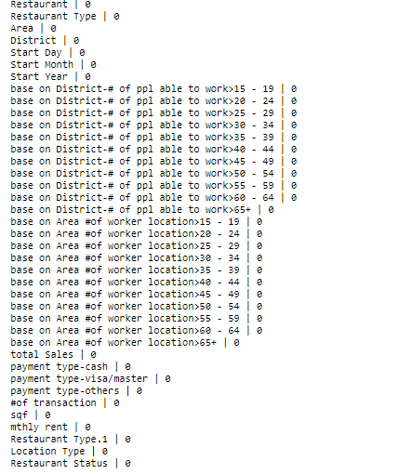

Figure 31: Null Values of each columns

Figure 31 is showing that there is no null value in the dataset.

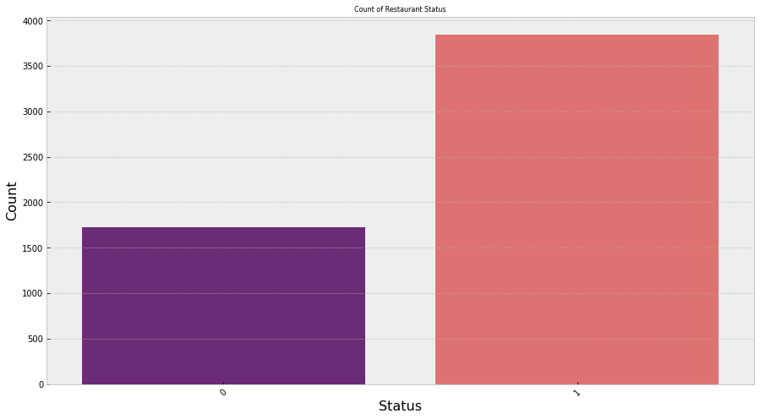

Figure 32: Count of Restaurant Status

Figure 30 is showing that Almost more then 1500 restaurants were not open, but more than 3500 restaurants were open.

Boxplot for distributions of each feature

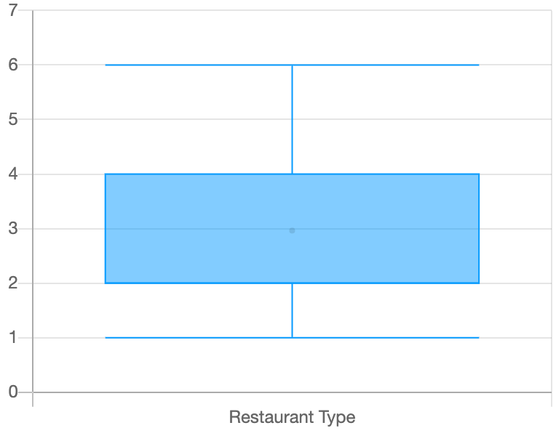

Figure 33 Boxplot visualization for restaurant type

It can be seen that mostly data belongs to first 4 types of restaurants.

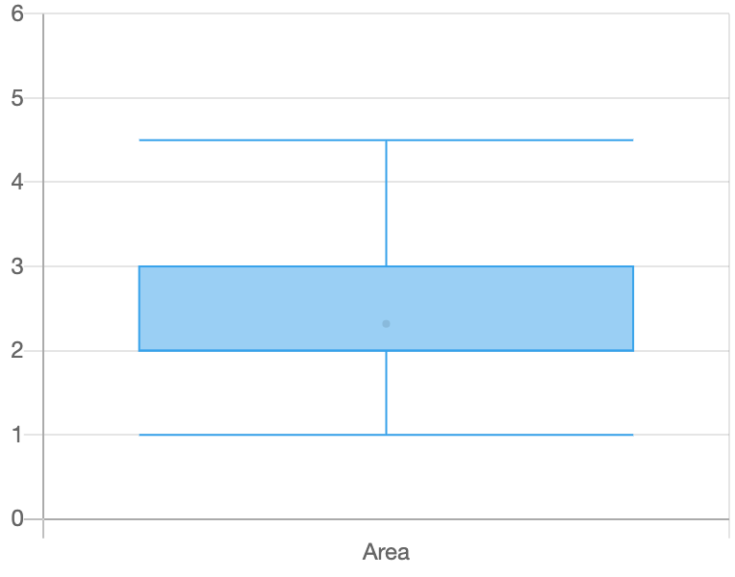

Figure 34: Boxplot visualization for restaurant area

It can be seen that most of the values belongs to first 4 areas instead of the fifth area.

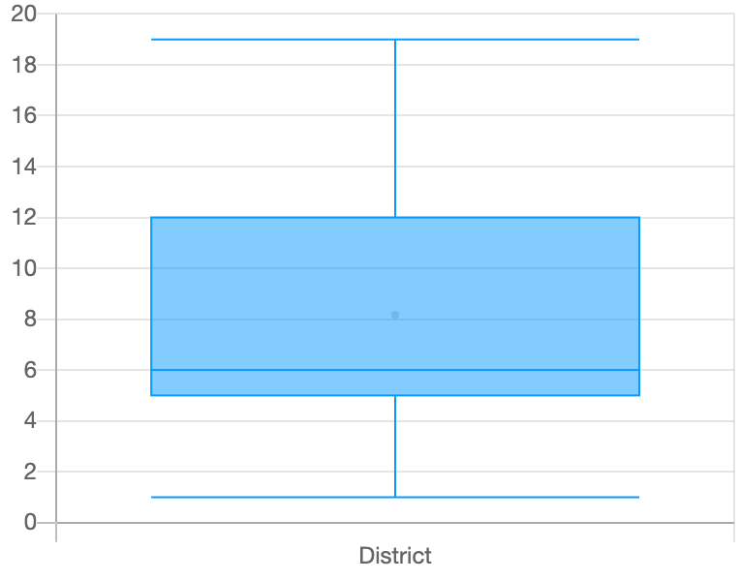

Figure 35: Boxplot visualization for Districts

It can be seen that 80% of the data lies in first 12 districts.

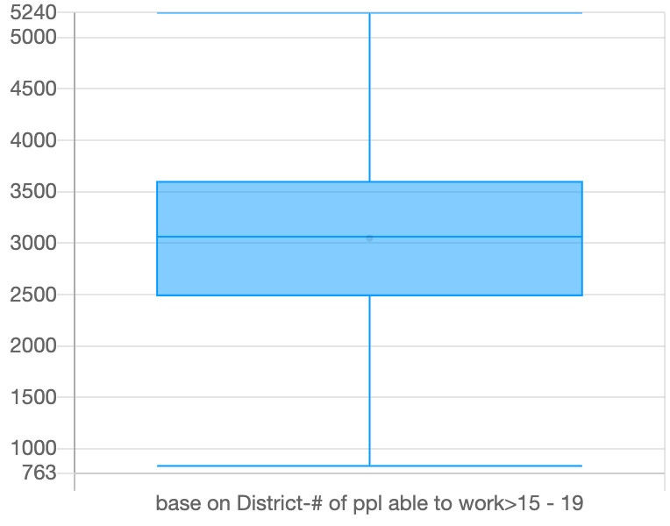

Figure 36: Boxplot of Number of people able to work from age 15 to 19 base on District

It can be seen that in districts there are mostly 2500 to 3500 people are available to work under 19.

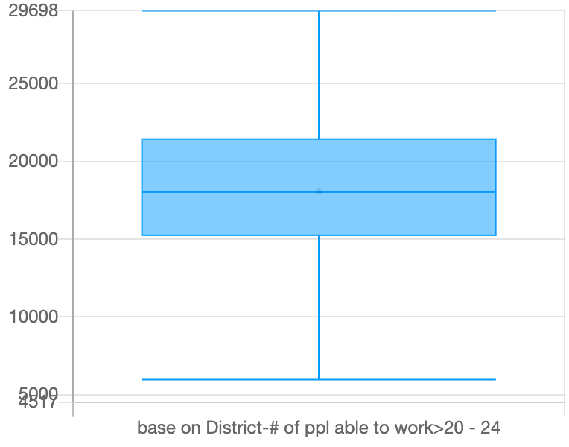

Figure 37: Boxplot of Number of people able to work from age 20 to 24 base on District

It can be seen that in districts there are mostly 15000 to 22000 people are available to work for age 20 to 24.

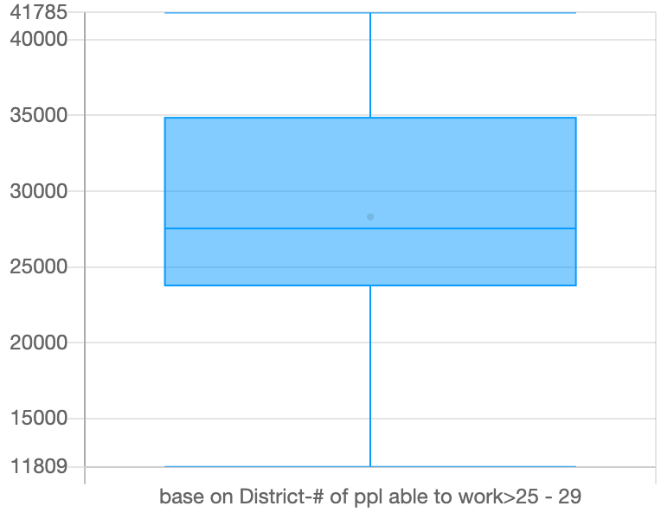

Figure 38: Boxplot of Number of people able to work from age 25 to 29 base on District

It can be seen that in districts there are mostly 24000 to 35000 people are available to work for age 25 to 29.

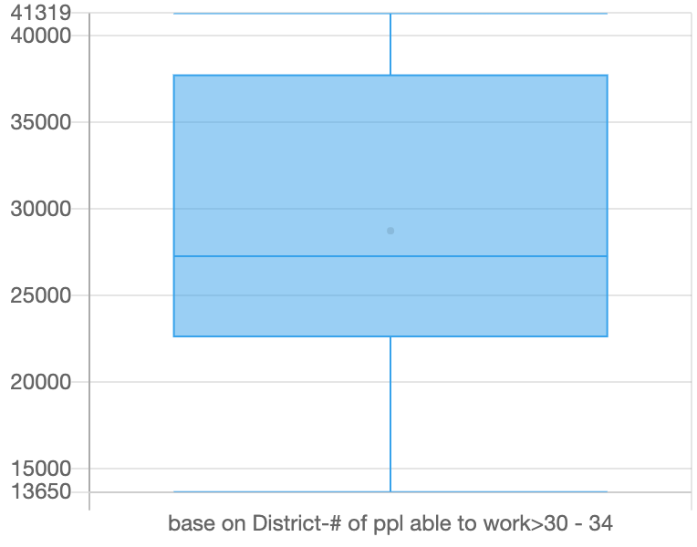

Figure 39: Boxplot of Number of people able to work from age 30 to 34 base on District

It can be seen that in districts there are mostly 23000 to 37000 people are available to work for age 30 to 34.

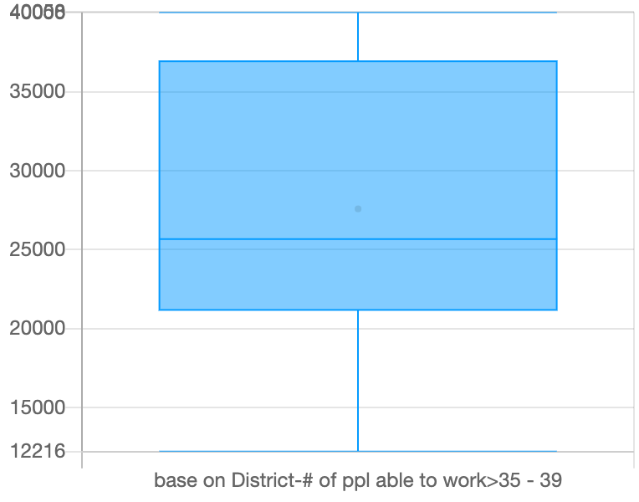

Figure 40: Boxplot of Number of people able to work from age 35 to 39 base on District

It can be seen that in districts there are mostly 22000 to 36000 people are available to work for age 35 to 39.

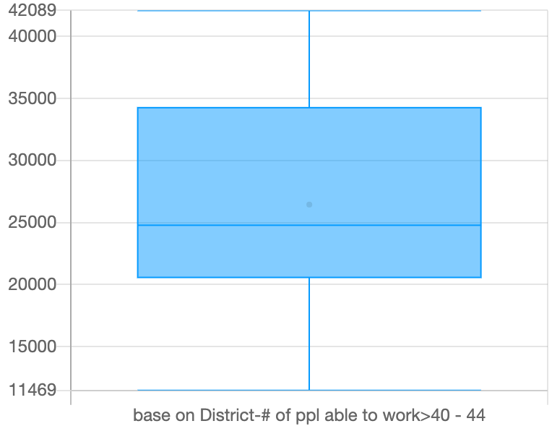

Figure 41: Boxplot of Number of people able to work from age 40 to 44 base on District

It can be seen that in districts there are mostly 20000 to 35000 people are available to work for age 40 to 44.

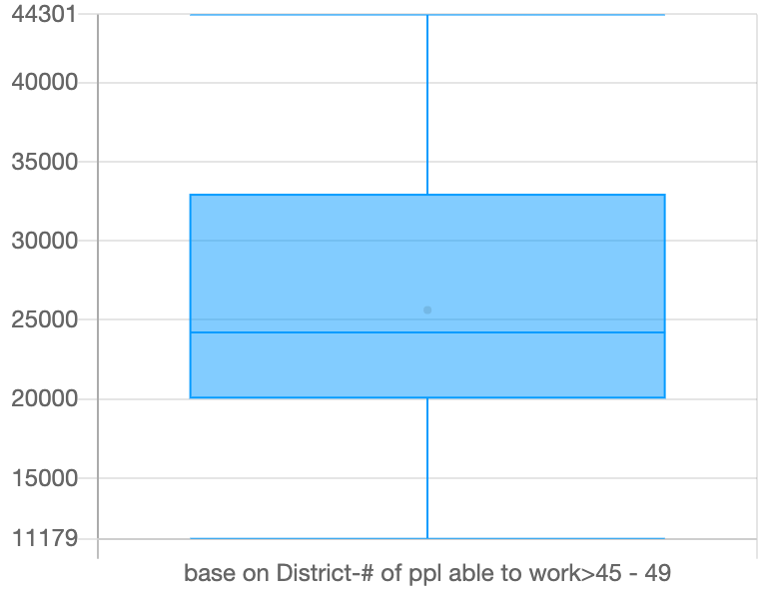

Figure 42: Boxplot of Number of people able to work from age 45 to 49 base on District

It can be seen that in districts there are mostly 20000 to 34000 people are available to work for age 45 to 49.

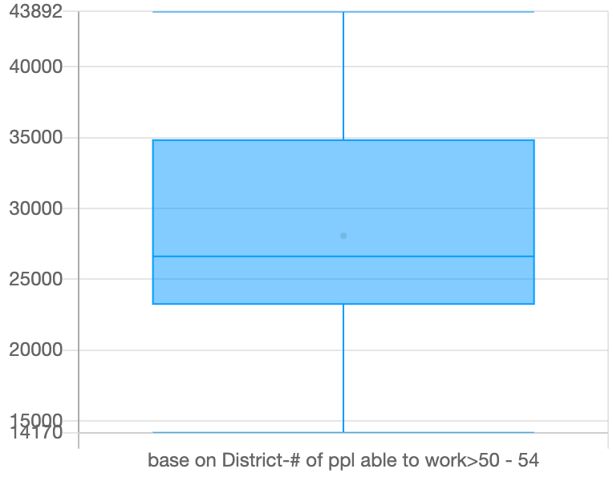

Figure 43: Boxplot of Number of people able to work from age 50 to 54 base on District

It can be seen that in districts there are mostly 24000 to 35000 people are available to work for age 50 to 54.

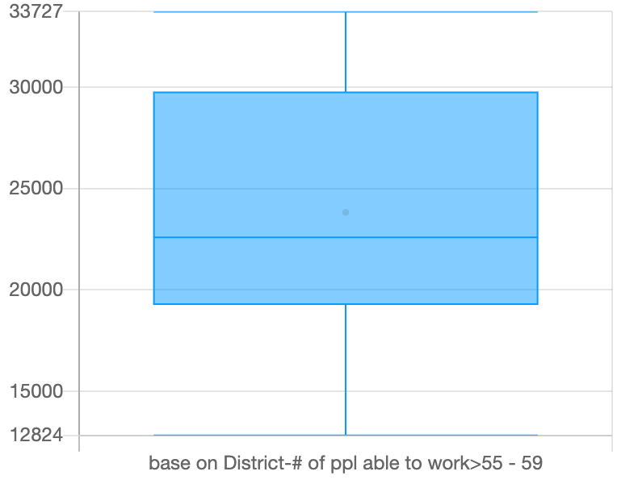

Figure 44: Boxplot of Number of people able to work from age 55 to 59 base on District

It can be seen that in districts there are mostly 18000 to 30000 people are available to work for age 55 to 59.

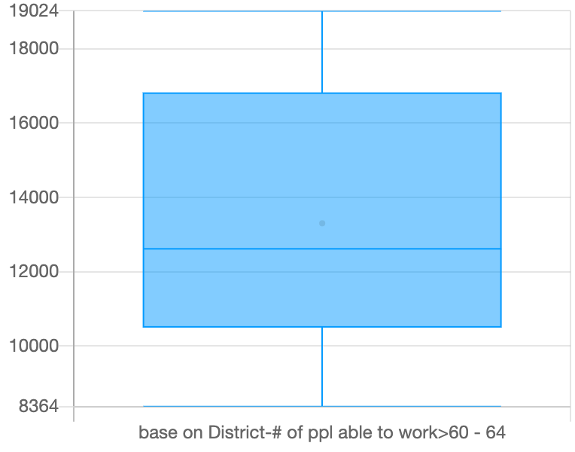

Figure 45: Boxplot of Number of people able to work from age 60 to 64 base on District

It can be seen that in districts there are mostly 12000 to 17000 people are available to work for age 60 to 64.

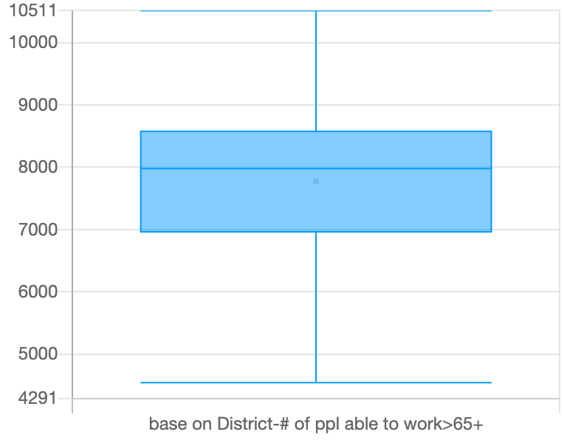

Figure 46: Boxplot of Number of people able to work from age 65 and above base on District

It can be seen that in districts there are mostly 7000 to 8500 people are available to work for age 65 and above.

Overall, It can also be concluded that mostly available for work are of age group are 20 to24.

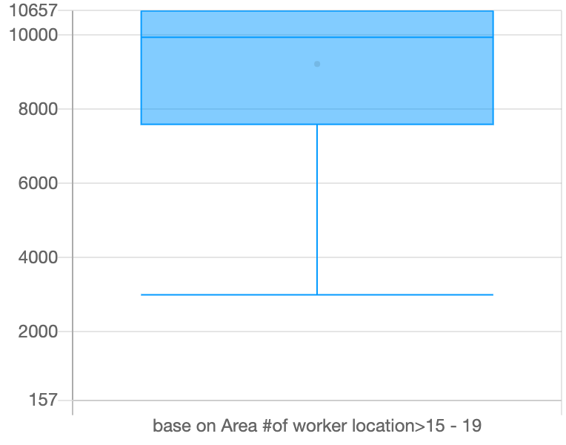

Figure 47: Boxplot of Number of people able to work from age 15 to 19 base on Area

It can be seen that mostly people below 19 are 7800 to 10500 in any restaurant base on Hong-Kong areas.

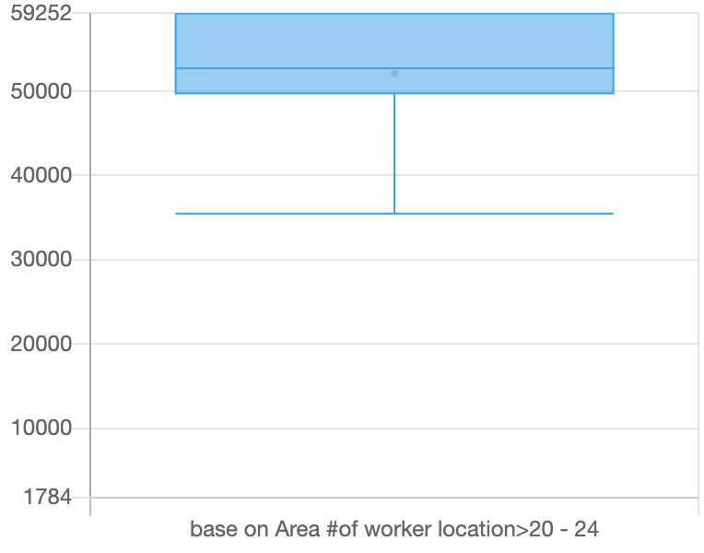

Figure 48: Boxplot of Number of people able to work from age 20 to 24 base on Area

It can be seen that mostly people from age 20 to 24 are 50000 to 60000 in any restaurant base on Hong-Kong areas.

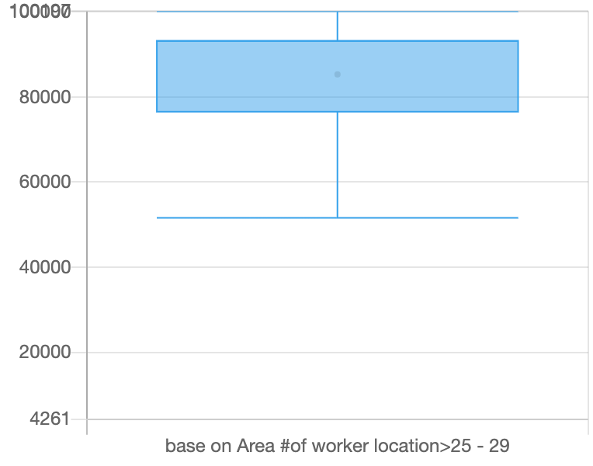

Figure 49:Boxplot of Number of people able to work from age 25 to 29 base on Area

It can be seen that mostly people from age 25 to 29 are 80000 to 95000 in any restaurant base on Hong-Kong areas.

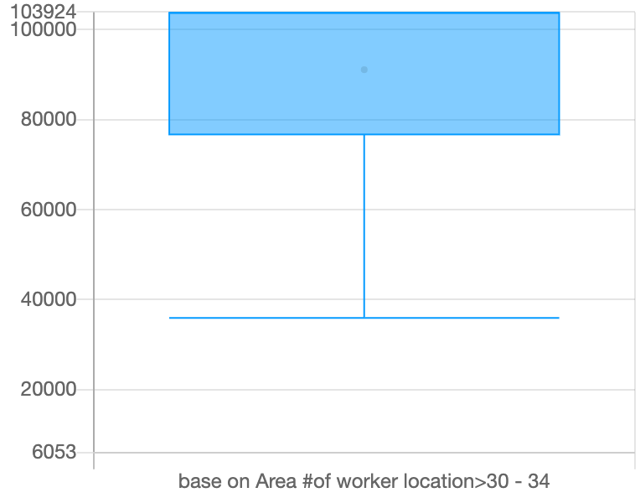

Figure 50: Boxplot of Number of people able to work from age 30 to 34 base on Area

It can be seen that mostly people from age 30 to 34 are 80000 to 100000 in any restaurant base on Hong-Kong areas.

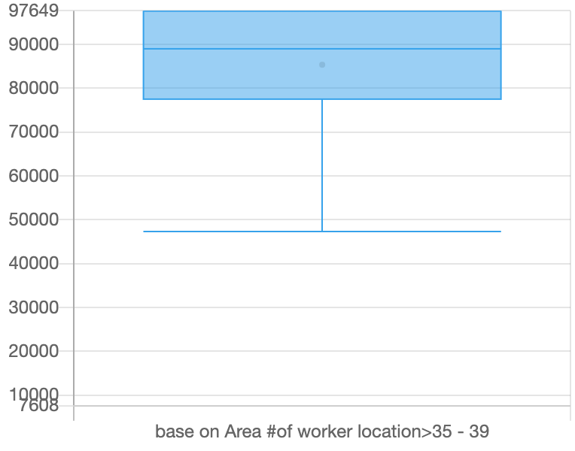

Figure 51: Boxplot of Number of people able to work from age 35 to 39 base on Area

It can be seen that mostly people from age 35 to 39 are 80000 to 98000 in any restaurant base on Hong-Kong areas.

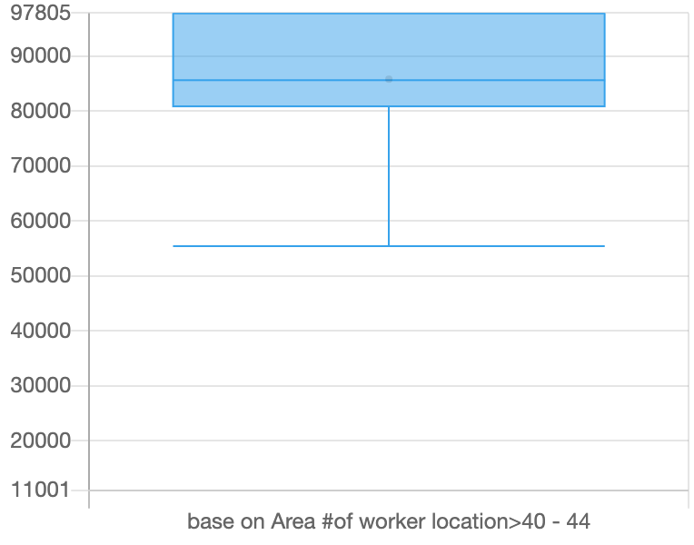

Figure 52: Boxplot of Number of people able to work from age 40 to 44 base on Area

It can be seen that mostly people from age 40 to 44 are 80000 to 98000 in any restaurant base on Hong-Kong areas.

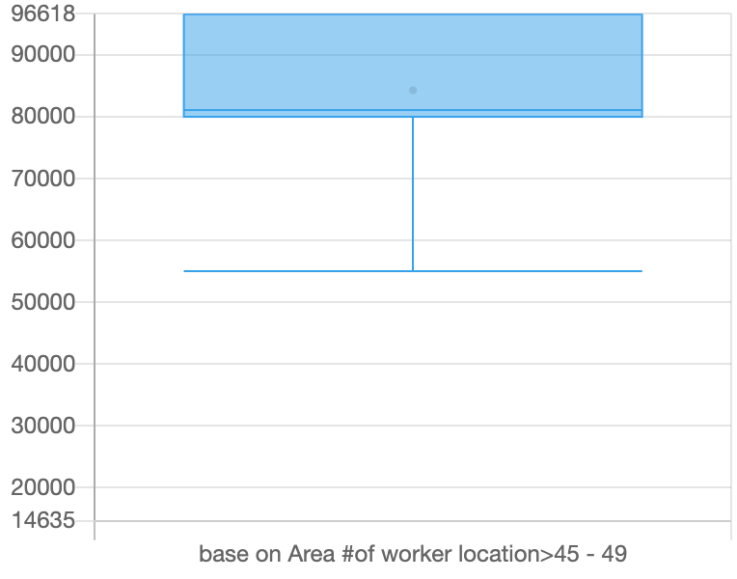

Figure 53: Boxplot of Number of people able to work from age 45 to 49 base on Area

It can be seen that mostly people from age 45 to 49 are 80000 to 98000 in any restaurant base on Hong-Kong areas.

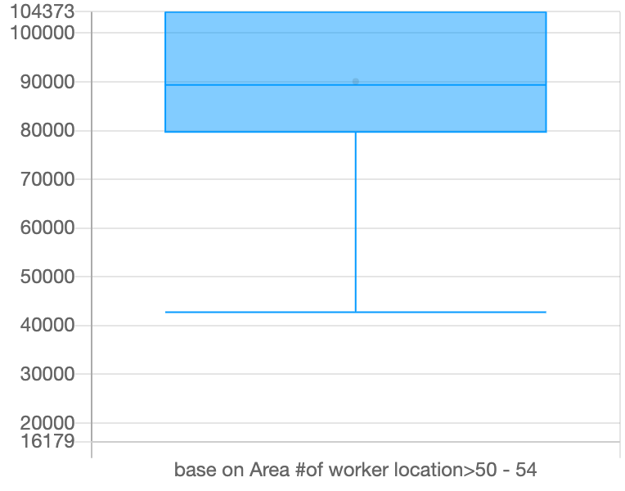

Figure 54: Boxplot of Number of people able to work from age 50 to 54 base on Area

It can be seen that mostly people from age 50 to 54 are 80000 to 101200 in any restaurant base on Hong-Kong areas.

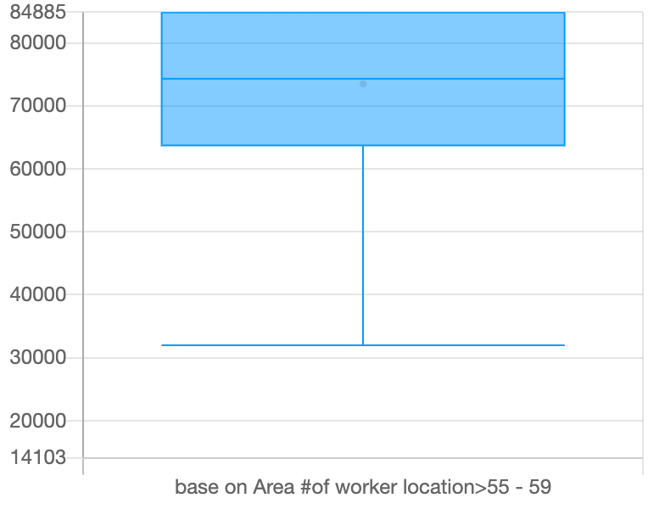

Figure 55: Boxplot of Number of people able to work from age 55 to 59 base on Area

It can be seen that mostly people from age 55 to 59 are 65000 to 85000 in any restaurant base on Hong-Kong areas.

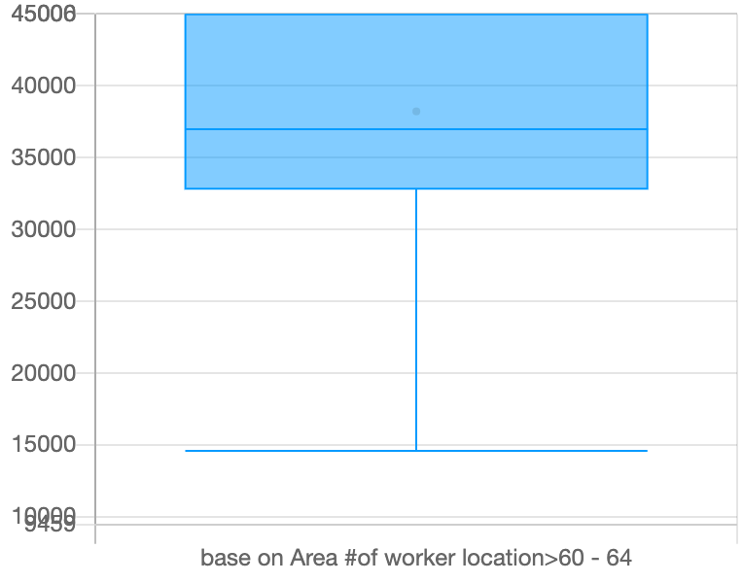

Figure 56: Boxplot of Number of people able to work from age 60 to 64 base on Area

It can be seen that mostly people from age 60 to 64 are 33000 to 45000 in any restaurant base on Hong-Kong areas.

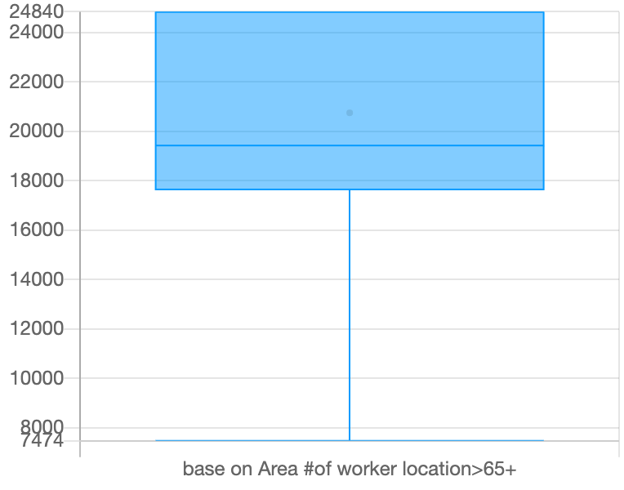

Figure 57: Boxplot of Number of people able to work from age 65 and above base on Area

It can be seen that mostly people from age 65 and above are 17500 to 25000 in any restaurant base on Hong-Kong areas.

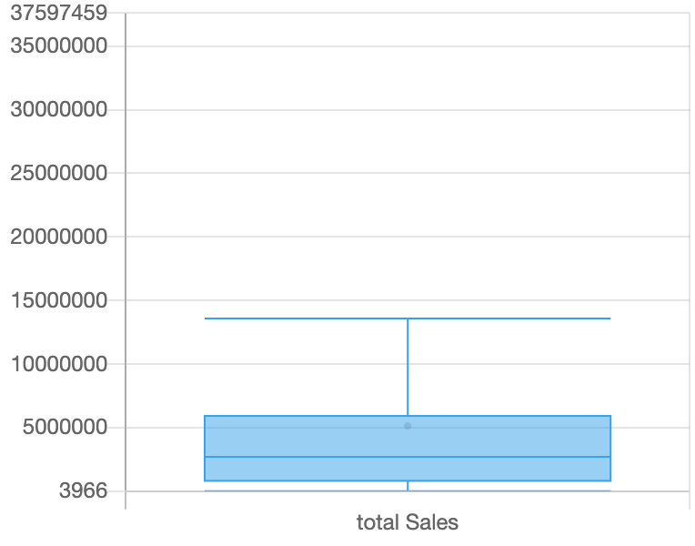

Figure 58: Boxplot of total sales

It can be seen that the total sales are mostly below 10,000,000

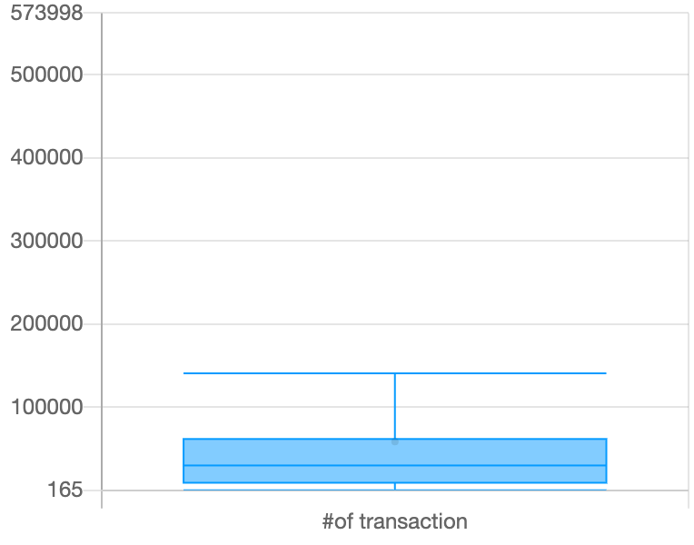

Figure 59: Boxplot of Number of transactions

It can be seen that the number of transactions are mostly below 150000.

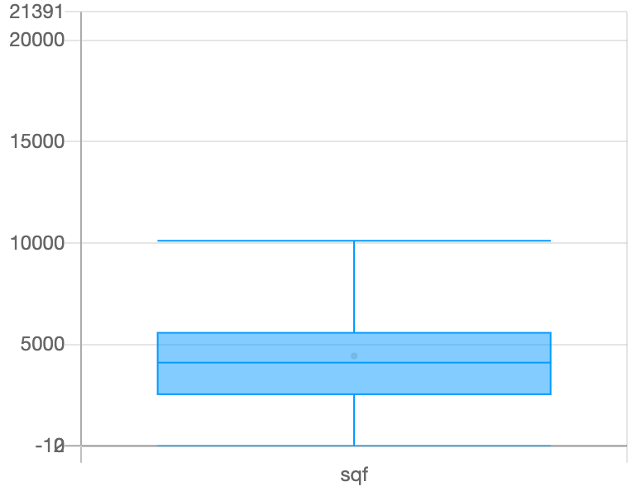

Figure 60: Boxplot of sqf

It can be seen that mostly values of sqf are below 10,000.

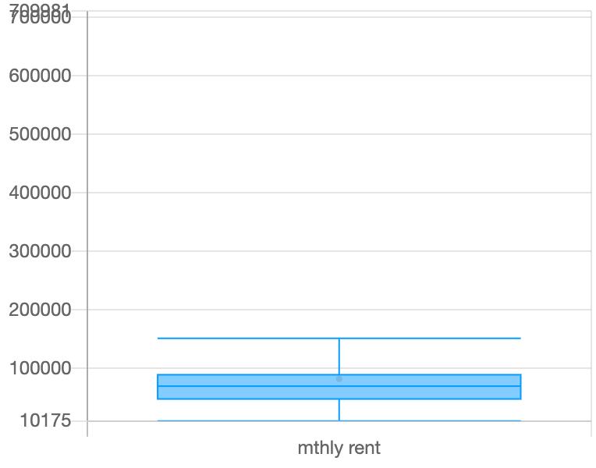

Figure 61: Boxplot of monthly rent

It can be seen that mostly values of monthly rent are below 180,000.

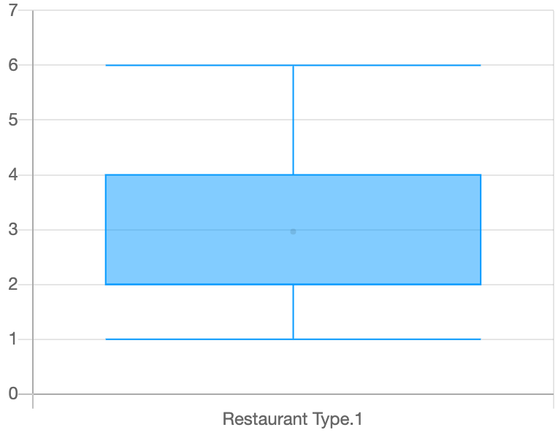

Figure 62: Boxplot of restaurant types

It can be seen that mostly monthly values belong to first 4 types.

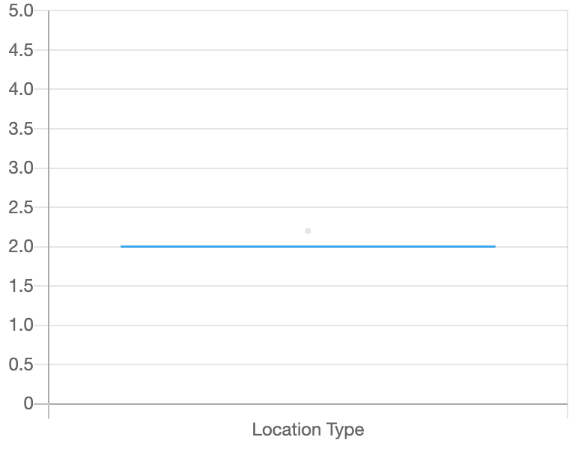

Figure 63: Boxplot of location types

It can be seen that mostly the 2nd location has more users.

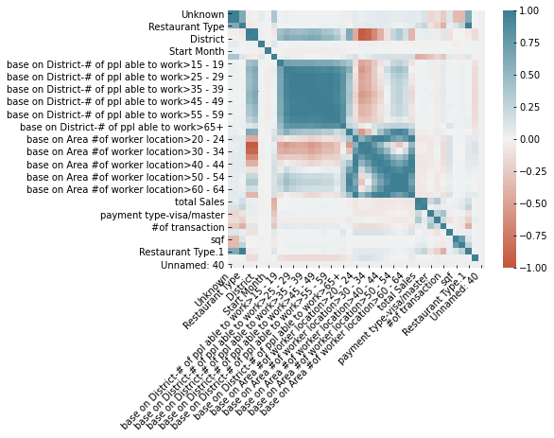

Figure 64: Co relation plot for all features

The above figure us showing that total sales only have good co relation with number of transitions.

Classification Algorithms Results for Restaurant Status Prediction

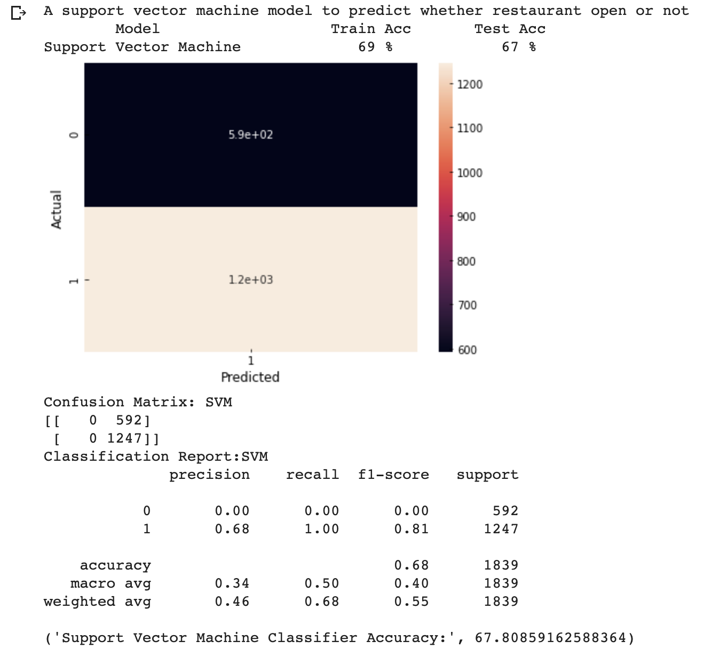

Figure 65: Results of Support Vector Machine Classifier for Restaurant Status Predictions

Figure 65 is showing the output of SVM model testing. It can be seen that model has wrongly predicted 565 not open status as open. Also, the accuracy becomes 68%. But this is showing that SVM isn’t the good algorithm for this purpose.

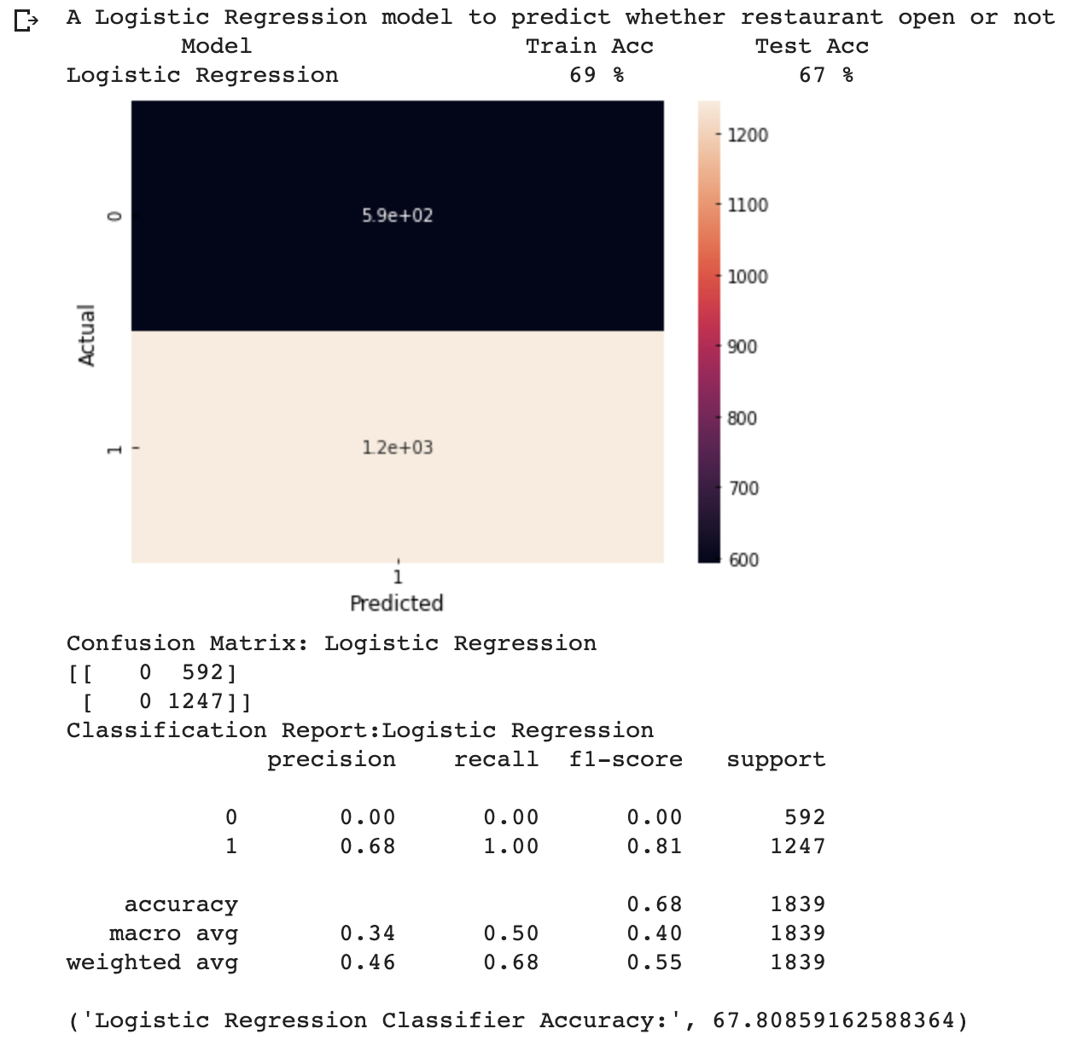

Figure 66: Results of Logistics Regression for Restaurant Status Predictions

Figure 66 is showing the output of Logistic model testing. It can be seen that model has wrongly predicted 542 not open status as open. Also, the accuracy becomes 69%. But this is showing that Logistic Regression isn’t the good algorithm for this purpose.

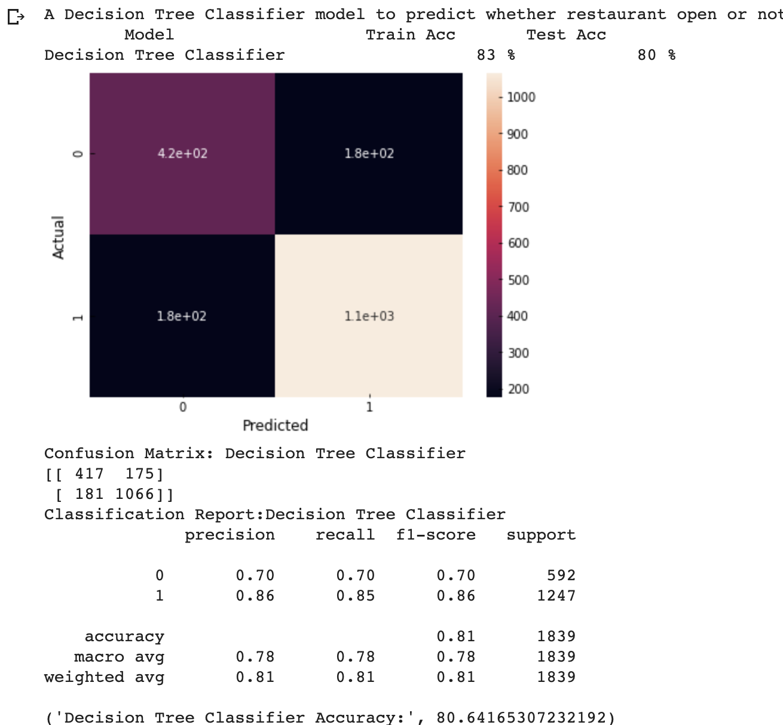

Figure 67: Result of decision tree Classifier for restaurant status prediction

Figure 67 is showing the output of Decision Tree Classifier testing. It can be seen that model has wrongly predicted 91 not open status as open. Also, the accuracy becomes 80%. But this is showing that Decision Tree classifier is a good algorithm for this purpose.

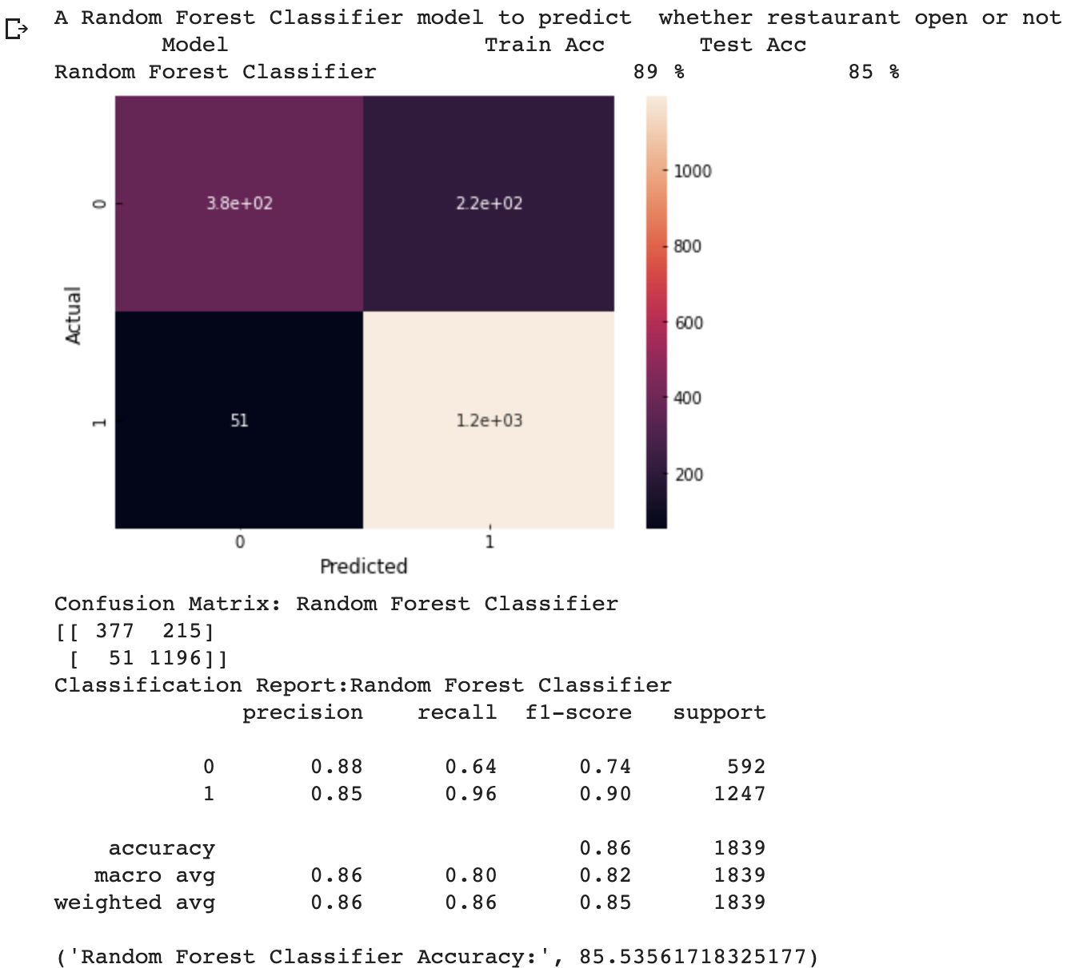

Figure 68: Results of random forest for restaurant status prediction

Figure 68 is showing the output of Random Forest Classifier testing. It can be seen that model has wrongly predicted 42 not open status as open. Also, the accuracy becomes 85%. But this is showing that Random Forest classifier is a good algorithm for this purpose.

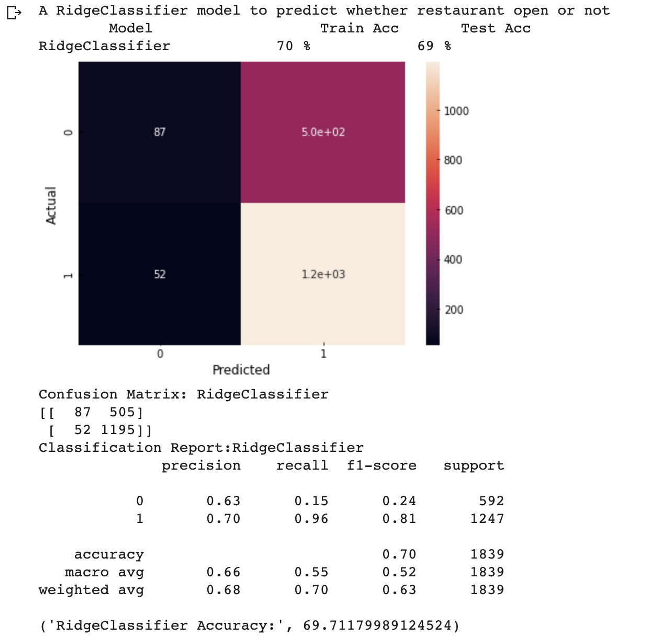

Figure 69: Results of ridge classifier for restaurant status Prediction

Figure 69 is showing the output of Ridge Classifier testing. It can be seen that model has wrongly predicted 351 not open status as open. Also, the accuracy becomes 69%. But this is showing Ridge Classifier is an average algorithm for this purpose.

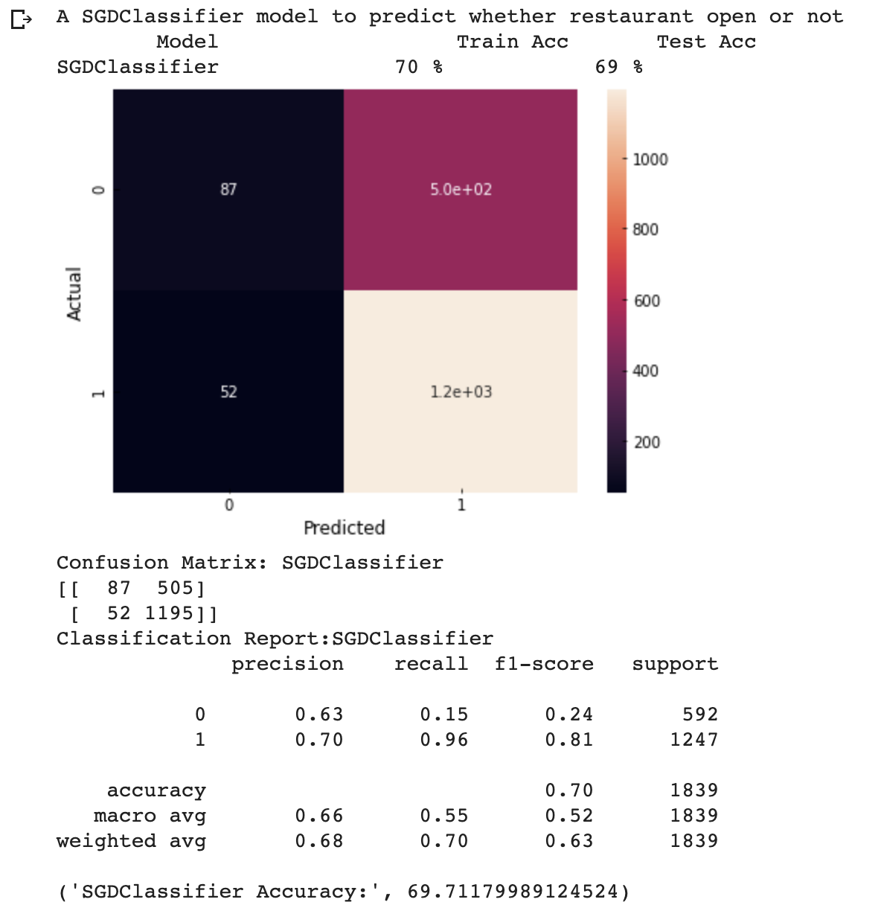

Figure 70: Results of SGD Classifier for restaurant status prediction

The above figure is showing the output of SDG Classifier testing. It can be seen that model has wrongly predicted 351 not open status as open. Also, the accuracy becomes 69%. But this is showing SDG Classifier is an average algorithm for this purpose.

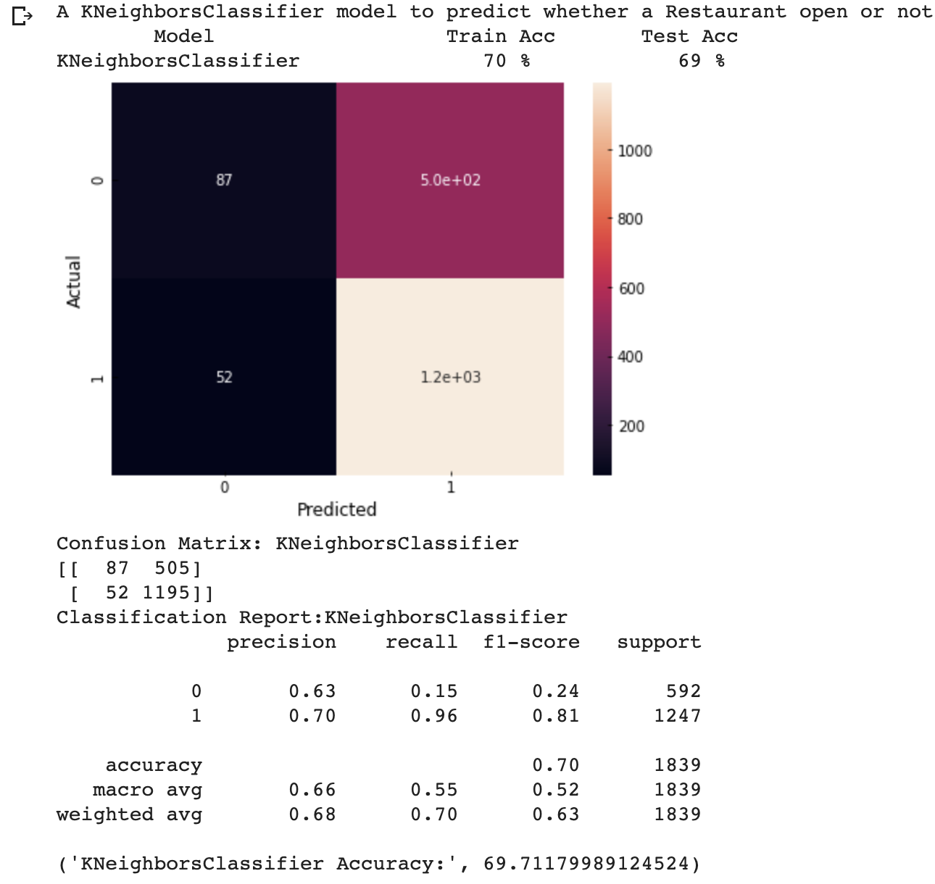

Figure 71: Results of K Neighbor classifier for restaurant status predictions

The above figure is showing the output of KNN Classifier testing. It can be seen that model has wrongly predicted 351 not open status as open. Also, the accuracy becomes 69%. But this is showing KNN Classifier is an average algorithm for this purpose.

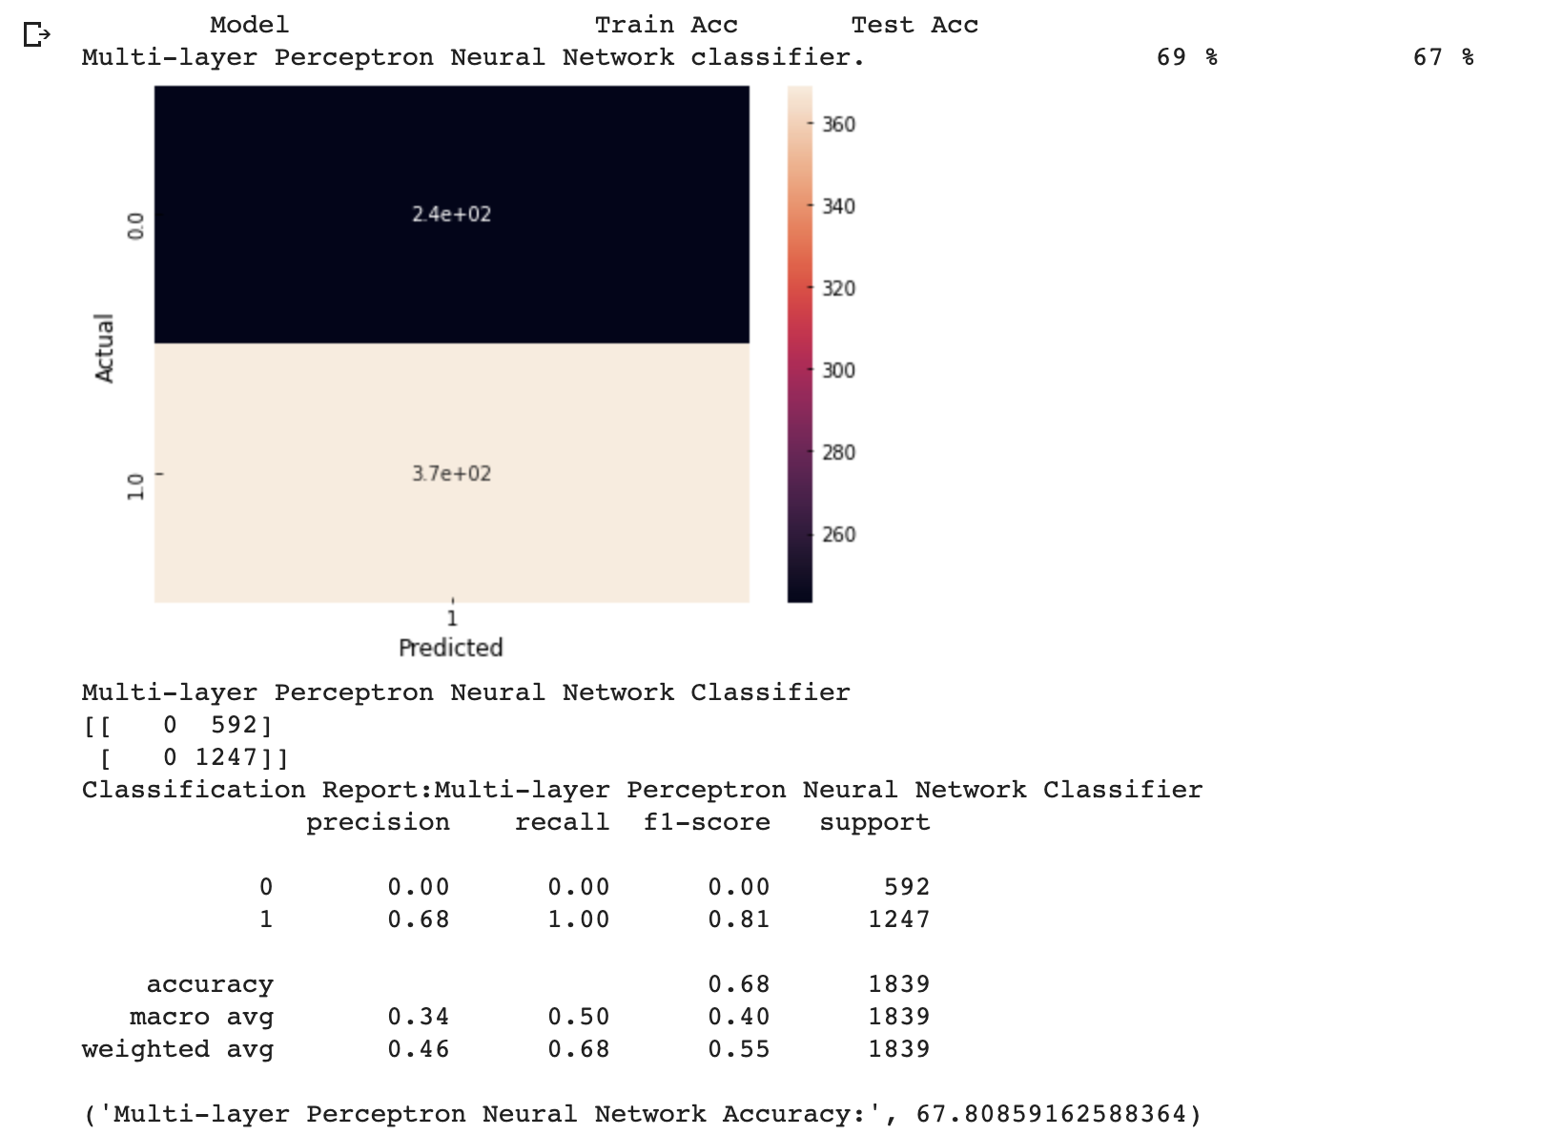

Figure 72: Results MLP classifier for restaurant status predictions

The above figure is showing the output of MLP Classifier testing. It can be seen that model has wrongly predicted 565 not open status as open. Also, the accuracy becomes 67%. This is showing MLP Classifier is a bad algorithm for this purpose.

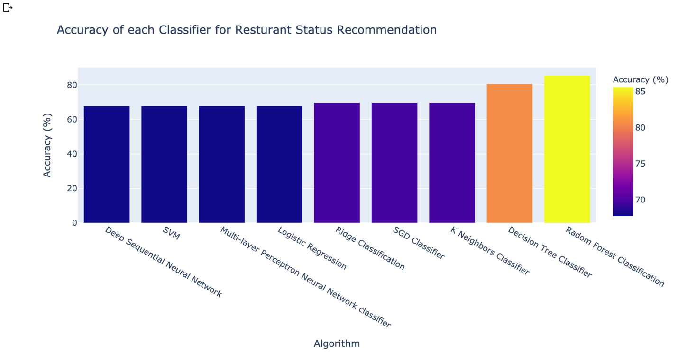

Figure 73: Restaurants Recommendations accuracy comparisons

The above Figure is showing that random forest classification has achieved the best accuracy for restaurant status Predictions.

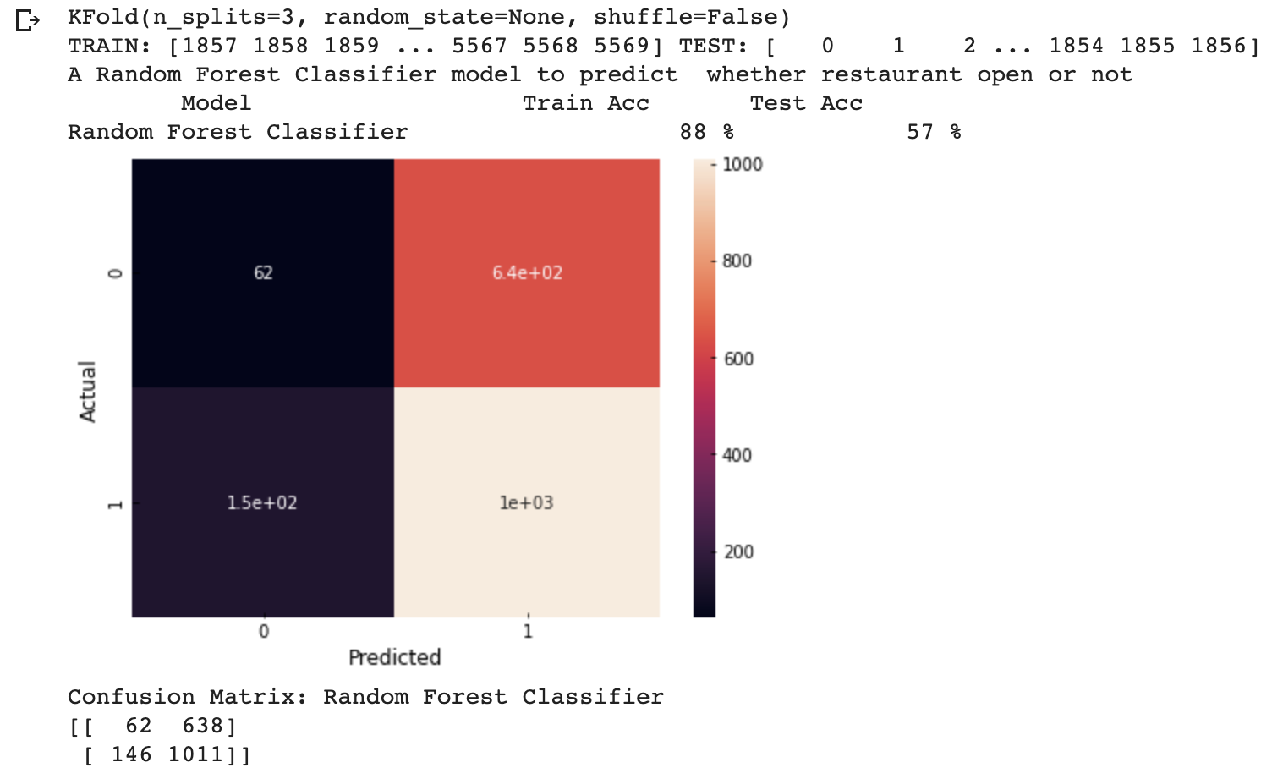

Figure 74: K fold validation step-1 results

K- Fold Validation was applied on Random Forest Classification. But it can be seen the random forest isn’t a sensible for the case where we are predicting based on increasing value.

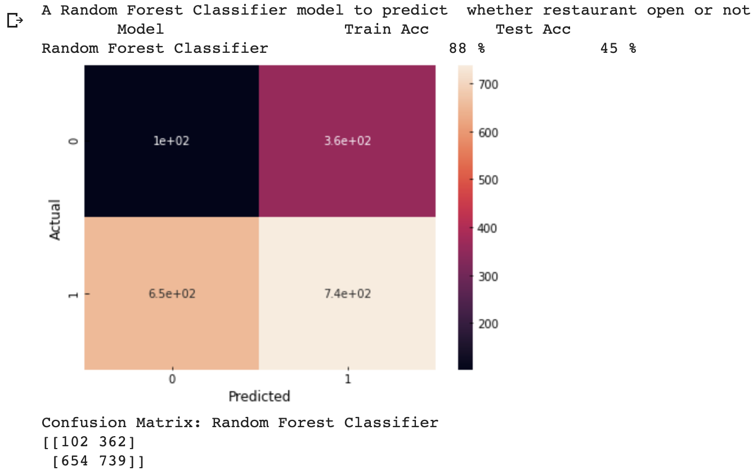

Figure 75: K Fold validation step 2 results

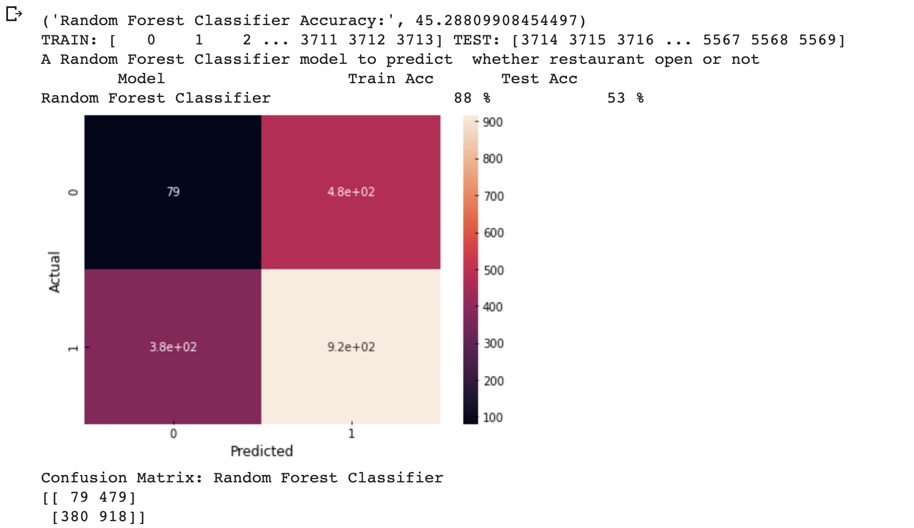

Figure 76: K Fold Validating step 3 results

Figure 75 and 76 are also showing that K Fold Cross Validation technique has proven the random forest is also so much not suitable for the purpose, but it is also showing that selecting the training and testing randomly is very important.

Regression Algorithms Results for Total Sales Prediction

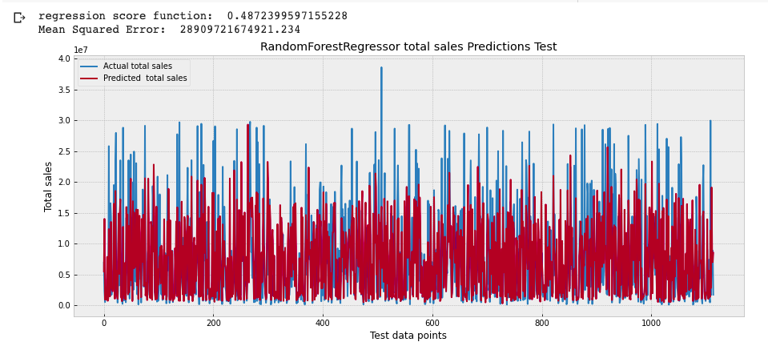

Figure 77: Random Forest Regression total sales predictions original and Predicted results for test data points

The above figure is showing that random forest has mostly high mean square root but it has good regression score function.

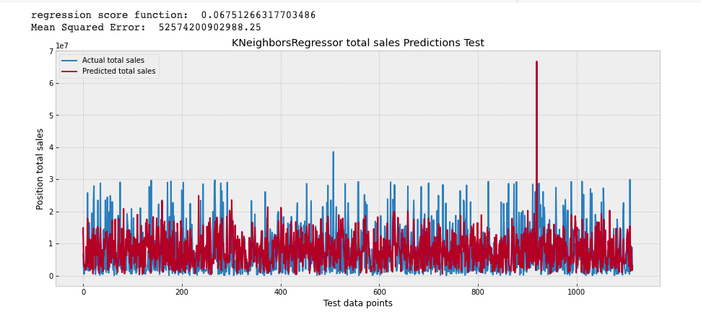

Figure 78: K Neighbor Regression total sales predictions original and Predicted results for test data points

The above figure is showing that K Neighbor regression is also mostly high mean square root but it has good regression score function.

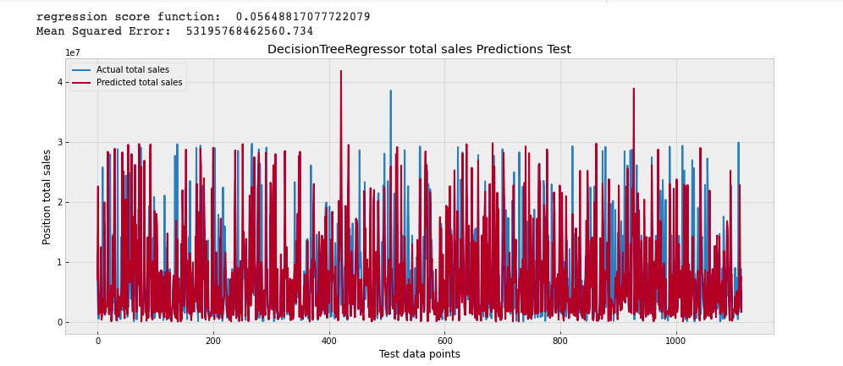

Figure 79: Decision Tree Regression for total sales predictions original and Predicted results for test data points

The above figure is showing that Decision Tree regression is also mostly high mean square root but it has good regression score function.

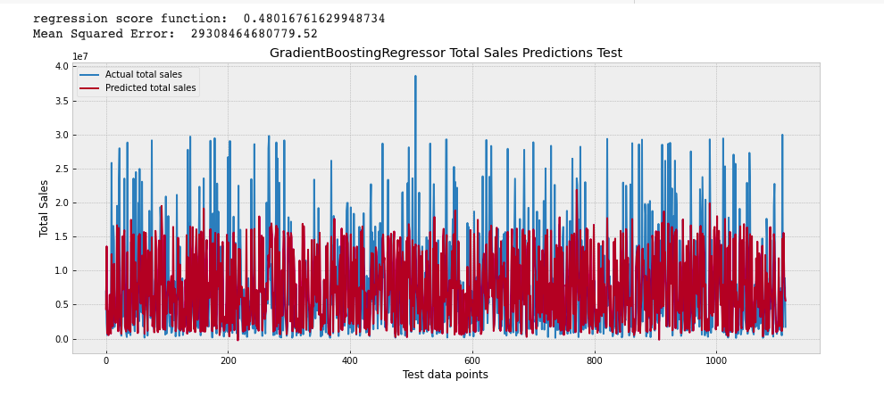

Figure 80: Gradient Boosting Regression for total sales predictions original and Predicted results for test data points

The above figure is showing that Decision Tree regression is also mostly high mean square root and also it does not have a good regression score function.

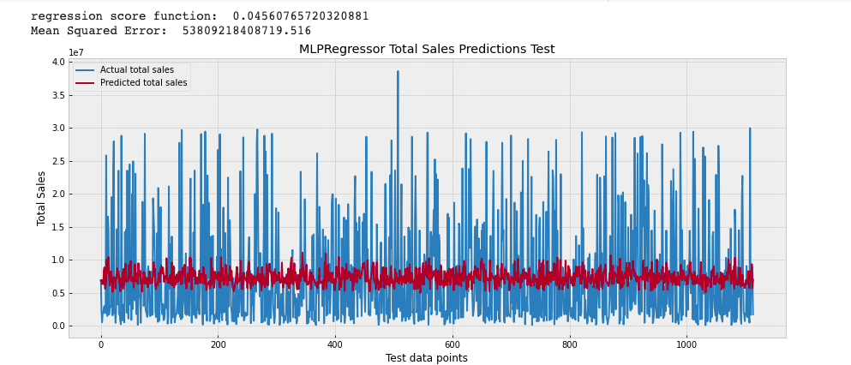

Figure 81: MLP Regression for total sales predictions original and Predicted results for test data points

The above figure is showing that MLP is also mostly high mean square root and also it does not have a good regression score function.

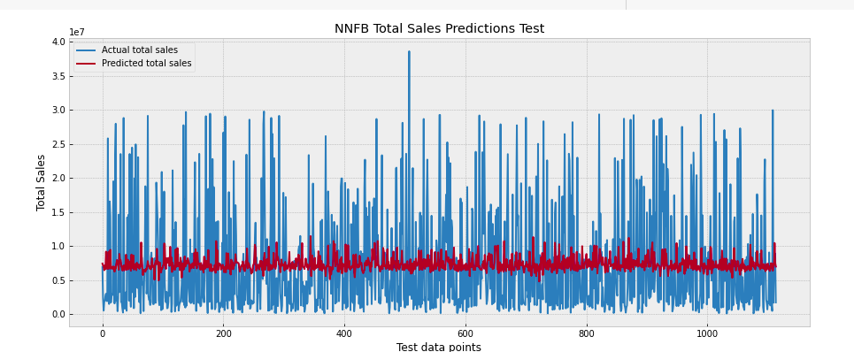

Figure 82: Neural Network Regression for total sales predictions original and Predicted results for test data points

The above figure is showing that Neural Network is also mostly high mean square root and also it does not have a good regression score function.

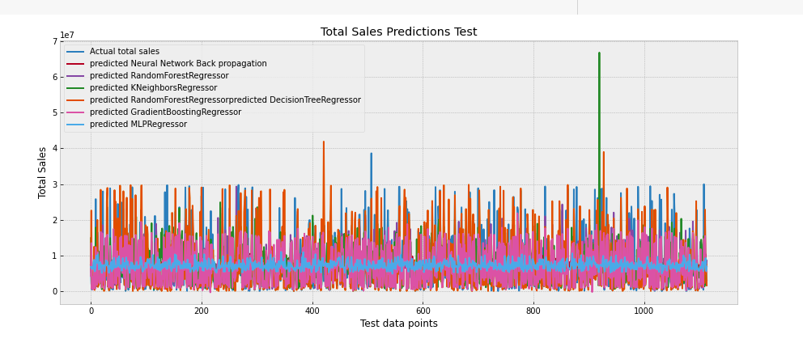

Figure 83: Combined plot for regression results

The combined plot is showing that there are differences in prediction of each algorithm.

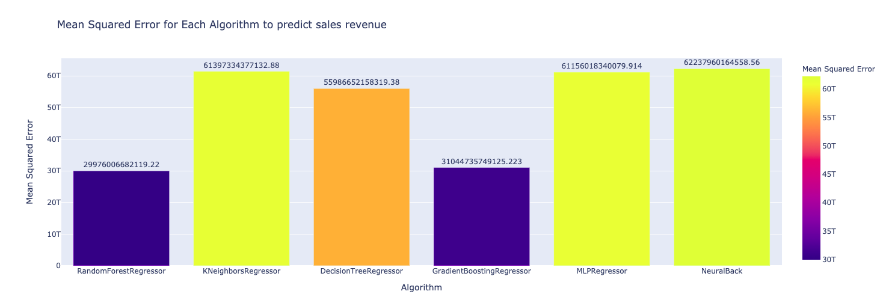

Figure 84: Mean Squared Algorithm for each algorithm to predict sales

The above figure is showing that K Neighbor Regression has the minimum mean squared error.

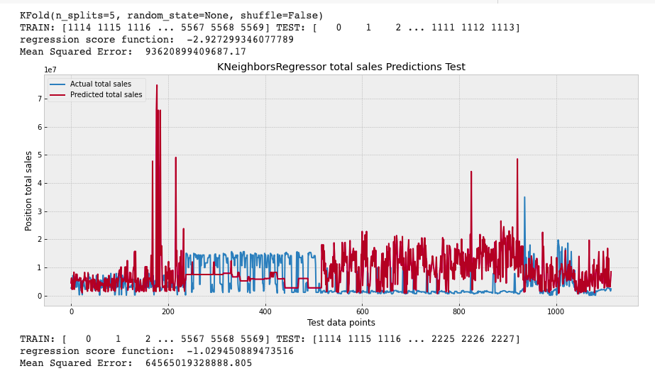

Figure 85: K Fold Validation Split 1 results

Cross Validation using K Neighbor Regression was done.

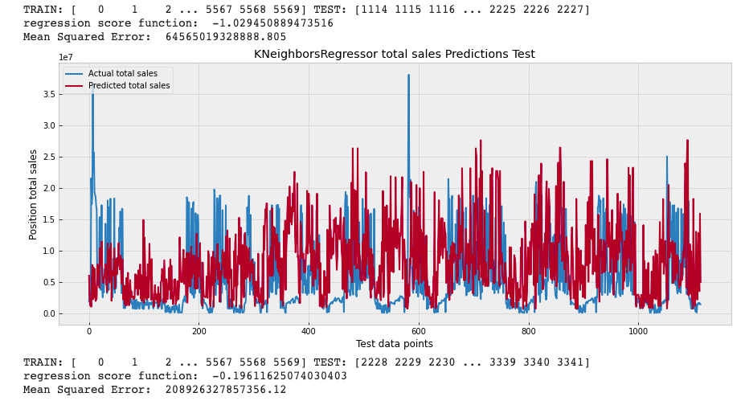

Figure 86: K Fold Validation Split 2 results

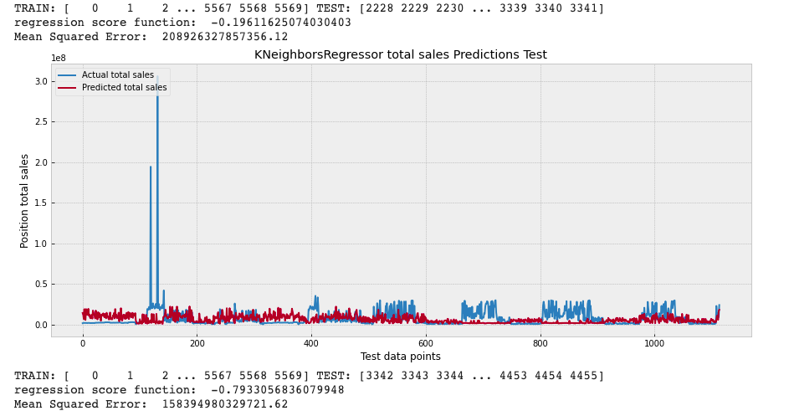

Figure 87: K Fold Validation split 3 results

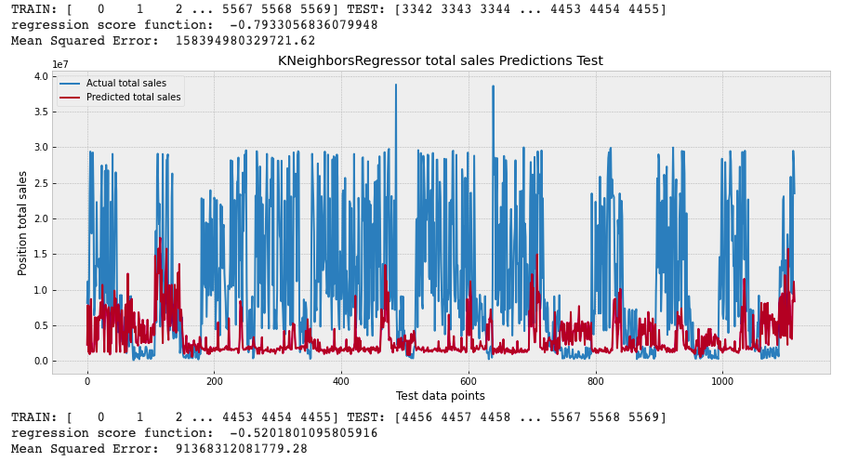

Figure 88: K Fold Validation split 4 results

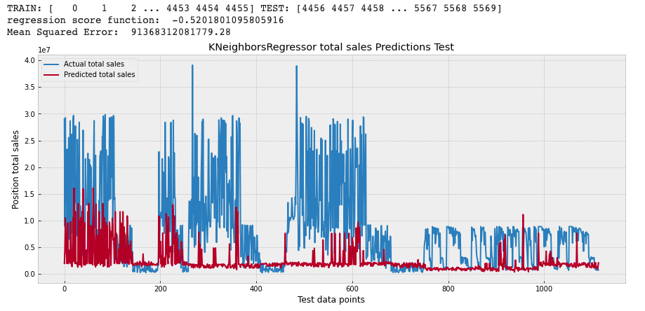

Figure 89: K Fold Validation split 5 results

Figure 85 to 89 are showing that it is difficult to predict the increasing and decreasing the price when we have 1125 continuous values are predicted. It can be seen that continues selection is not reasonable and hence the random selection should be done for the model to perform best.

## **Discussions**

From above results it can be seen that mostly people of age 20 to 24 are available in any District. In any area the age group 25 to 44 is very much active. It can be said that the continues data is difficult to predict and to tune the model random section of rows must be done.

## **Chapter summary**

Given its popularity, rate of adoption, and flexibility, Python is often the preferred language for machine learning development. There are many available Python packages to perform numerous tasks, including data cleaning, visualization, and model development. Some of these key packages are Scikit-learn and Keras. The seven steps of model development mentioned in this chapter can be leveraged while developing any machine learning based model in our case.

# **CHAPTER 5:**

# **CONCLUSIONS**

## **Key Findings**

From this research it was checked that the data selection to fit in algorithms must be selected randomly for more accuracy. It was checked that Random Forest Classification is the best algorithm for the Restaurant Status Prediction. It was checked that K Neighbor Regression is one of the best algorithms for total sales predictions. It was also checked that mostly people available for working in Hong Kong are from age 20 to 40.

## **Limitations**

When K Fold Cross Validation was applied on the best algorithms for both cases the accuracy was dropped hence the random selection of data should be done to get the accurate results.

The dataset was relatively small then the total number of Restaurants in the Hong Kong hence in future more data is needed.

## **Recommendations and Further Studies**

In future more, data can be added to fit into the algorithms so that they can be more accuracte. In future parameter tuning can also be done to get maximum accuracy for each algorithm.

## **Social, Ethical, Professional and Legal Issues**

Client purposed to develop innovations of technology sides and kept close tracks on restaurants opening and sales and predictions. Though this research adopted hotels data with no personal privacy concerns.

**5.4.1 Social issues**

The insight provided from the predication model is purposed for internal use. The poor performance causes reputation risk and loss business shares to the client.

**5.4.2 Ethical issues**

The prediction model is a kind of tool for recommendation for experience user but still

required some knowledges and not blindly following the prediction. Misunderstanding or

misuses on the model may produce wrong result but some results may be downtrend due to significant information disclosure (profit warning).

5.4.2 **Professional issues**

The model is only applied to Hong Kong Restaurants, not universal model on various restaurants. Misuse on model may produce revenue loss and reputation risk. The model users should be well-known the model usage. The prediction has no guarantee accuracy.

**5.4.3 Legal issues**

Client must not directly provide the prediction result to its customers as the restaurant opening

advices. Wrong prediction may make revenue loss to client’s customers. Client should

be known that restaurant advice should be provided by licensed person and client has to make a clear internal announcement for the usage of prediction model. To conclude, these concerns are mainly related to the use of models. Sufficient instructions, user’s manual and user training can solve these concerns.

## **Putting it Together: Conclusions**

In conclusion, the research has fulfilled the client’s requirements in chapter 1.3 and Project Objectives in 1.4. The aim of this research is to use ML supervised classifications to predict restaurant’s status prediction and to use regression models to predict restaurant’s sales prediction. This research provided the literature review of related work and demonstrate the complete data product development methodology. Results evaluations and visualizations are also added. This research shows the Random Forest Classification is best algorithm for restaurant’s status prediction and K Neighbor Regression is the best algorithm for restaurant’s sales prediction.

What’s Next for me?

This is just the beginning of our journey. The ML field is rapidly growing every single year. I was learning how to build ML product which publicly available for F&B industry to widely use it on Web. The future is bright for ML, and now that I learned these courses are better equipped to learn more about deeper subtopics like reinforcement learning, deep learning, artificial intelligence in general, and more complicated ML algorithms to be able to launch the data product publicly.

# **References**

(Van Der Malsburg, 1986, Brown and Mitchell, 1993, Wolpert, 1996, Pinkus, 1999, Platt, 2001, Bilenko and Mooney, 2003, Kim and Gu, 2006, Cutler et al., 2007, Schrouff et al., 2013, Larson and Chang, 2016, Lasek et al., 2016a, Lasek et al., 2016b, Nam et al., 2016, Lian et al., 2017b, Lian et al., 2017a, Khan and Roy, 2018, Te et al., 2018, Adolfsson and Andersson, 2019, Gressling, 2020, Shrove and Jovanov, 2020, Varatharajan et al., 2020)

ADOLFSSON, R. & ANDERSSON, E. 2019. Improving sales forecast accuracy for restaurants.

BILENKO, M. & MOONEY, R. J. Adaptive duplicate detection using learnable string similarity measures. Proceedings of the ninth ACM SIGKDD international conference on Knowledge discovery and data mining, 2003. 39-48.

BROWN, K. A. & MITCHELL, T. R. 1993. Organizational obstacles: Links with financial performance, customer satisfaction, and job satisfaction in a service environment. *Human relations,* 46**,** 725-757.

CUTLER, D. R., EDWARDS JR, T. C., BEARD, K. H., CUTLER, A., HESS, K. T., GIBSON, J. & LAWLER, J. J. 2007. Random forests for classification in ecology. *Ecology,* 88**,** 2783-2792.

GRESSLING, T. 2020. 36 Second generation: classification. *Data Science in Chemistry.* De Gruyter.

KHAN, P. M. & ROY, K. 2018. Current approaches for choosing feature selection and learning algorithms in quantitative structure–activity relationships (QSAR). *Expert opinion on drug discovery,* 13**,** 1075-1089.

KIM, H. & GU, Z. 2006. Predicting restaurant bankruptcy: A logit model in comparison with a discriminant model. *Journal of Hospitality & Tourism Research,* 30**,** 474-493.

LARSON, D. & CHANG, V. 2016. A review and future direction of agile, business intelligence, analytics and data science. *International Journal of Information Management,* 36**,** 700-710.

LASEK, A., CERCONE, N. & SAUNDERS, J. 2016a. Restaurant sales and customer demand forecasting: Literature survey and categorization of methods. *Smart City 360°***,** 479-491.

LASEK, A., CERCONE, N. & SAUNDERS, J. 2016b. Smart Restaurants: Survey on customer demand and sales forecasting. *Smart Cities and Homes***,** 361-386.

LIAN, J., ZHANG, F., XIE, X. & SUN, G. CCCFNet: a content-boosted collaborative filtering neural network for cross domain recommender systems. Proceedings of the 26th international conference on World Wide Web companion, 2017a. 817-818.

LIAN, J., ZHANG, F., XIE, X. & SUN, G. Restaurant survival analysis with heterogeneous information. Proceedings of the 26th International Conference on World Wide Web Companion, 2017b. 993-1002.

NAM, H., BAEK, M. & HAN, B. 2016. Modeling and propagating cnns in a tree structure for visual tracking. *arXiv preprint arXiv:1608.07242*.

PINKUS, A. 1999. Approximation theory of the MLP model. *Acta Numerica 1999: Volume 8,* 8**,** 143-195.

PLATT, J. C. 2001. Methods and apparatus for building a support vector machine classifier. Google Patents.

SCHROUFF, J., ROSA, M. J., RONDINA, J. M., MARQUAND, A. F., CHU, C., ASHBURNER, J., PHILLIPS, C., RICHIARDI, J. & MOURÃO-MIRANDA, J. 2013. PRoNTo: pattern recognition for neuroimaging toolbox. *Neuroinformatics,* 11**,** 319-337.

SHROVE, M. T. & JOVANOV, E. 2020. Early Outcome Prediction of Software Projects using Software Defects and Machine Learning. *Journal of Software Engineering Practice,* 4**,** 1-12.

TE, Y.-F., MULLER, D., WYDER, S. & PRAMONO, D. 2018. Predicting the Growth of Restaurants Using Web Data. *Economic and Social Development: Book of Proceedings***,** 237-256.

VAN DER MALSBURG, C. 1986. Frank rosenblatt: Principles of neurodynamics: Perceptrons and the theory of brain mechanisms. *Brain theory.* Springer.

VARATHARAJAN, M. N., GURUPRASAD, J. & MATHUMITHA, K. 2020. Restaurant Recommendation System Using Machine Learning. *International Educational Applied Research Journal,* 4**,** 1-4.

WOLPERT, D. H. 1996. The lack of a priori distinctions between learning algorithms. *Neural computation,* 8**,** 1341-1390.